**CHINMAYA COLLEGE OF ARTS COMMERCE AND SCIENCE**

**Layam Road, Tripunithura-682301**

***(Affiliated to Mahatma Gandhi University, Kottayam)***



**BACHELOR OF COMPUTER APPLICATIONS**

**MINI PROJECT**

**ON**

**EASTERN TREADS MANAGEMENT SYSTEM**

**Submitted By,**

**VISHALAKSHI V PRABHU**

**Reg. No: 150021239917**

**CHINMAYA COLLEGE OF ARTS COMMERCE AND SCIENCE**

**Layam Road, Tripunithura-682301**

***(Affiliated to Mahatma Gandhi University, Kottayam)***



**CERTIFICATE**

***This is to certify that the Project Report entitled***

**EASTERN TREADS MANAGEMENT SYSTEM**

***has been submitted by***

**VISHALAKSHI V PRABHU**

**Reg No: 150021239917**

***In partial fulfillment of the requirements for the award of the degree***

**BACHELOR OF COMPUTER APPLICATIONS**

**MAHATMA GANDHI UNIVERSITY**

***during the academic year 2017-2018***

***Submitted for the Seminar held on…………..…***

**PROJECT GUIDE**

PRINCIPAL EXTERNAL EXAMINER

**ACKNOWLEDGMENT**

**By blessings and permission of almighty God, I was able to complete this work. Sincere thanks to all the respected people who co-operated with me. I proudly pay my tribute and thanks to our Principal Mr. Ramakumar for his overwhelming and moral support extended towards us.**

**I express grateful thanks to Mrs. Manjusha (our respected guide), Mrs. Nisha, Mrs. Andal, Mrs. Sharmila for providing a healthy environment and for all timely assistance, advice, constant encouragements and invaluable guidance, offered to us make this project a success.**

**Finally I thank my parents for their boundless support and for making our lives so easy and for helping to tackle all those difficulties in our life.**

**VISHALAKSHI V PRABHU**

**DECLARATION**

I **VISHALAKSHI V PRABHU** , hereby declare that the project entitled “**EASTERN TREADS MANAGEMENT SYSTEM**” submitted to Mahatma Gandhi University , Kottayam in partial fulfillment of the requirements for the Bachelor’s degree in Computer Application is a record of original work done by me during the period of study at Chinmaya College of Arts , Commerce and Science , Tripunithura under the guidance of Mrs. Manjusha Jayakumar , Department of BCA and that this project work has not formed the basis for the reward of any diploma/associates-ship/fellowship or similar title to any candidates of any university**.**

**Place: VISHALAKSHI V PRABHU**

**Date: Reg No: 150021239917**

**SYNOPSIS**

The project entitled “**EASTERN TREADS MANAGEMENT SYSTEM**” and is developed and automated for EASTERN TREADS, located at Edapally to have a systemized and computerized tyre retreading process and to schedule them in an ordered manner.Currently the system which is now being used is manual.

My Visual Basic project developed and automated for the company mentioned above deals with almost all functionalities which are required for a retreading company for efficient processing like user login, in which different users of the system uses the application for a prescribed operation or function and the access for each of these user types are different, except for the admin for which he he/she has access to all the user operation. Other operations are assigning staff, managing sales,customer management, retreading management,purchase management etc. The software which is being designed will replace the existing manual system in all the ways, without any major changes and problems.

The front end of the project is Visual Basic 6.0 and backend is SQL Server 2008. Visual Basic is a third-generation event-driven programming language and integrated development environment (IDE) from Microsoft for its COM programming model first released in 1991 and declared legacy in 2008. SQL Server 2008 was released on August 6, 2008, announced to the SQL Server Special Interest Group at the ESRI 2008 User’s Conference on August 6, 2008 by Ed Katibah and aims to make data management self-tuning, self organizing, and self maintaining with the development of SQL Server.

**Table of Contents page no**

**1. Introduction 1**

**1.1. Project Overview 2**

**1.2. Organization Profile 4**

**1.3. Organization Chart 8**

**2. System Analysis 8**

**2.1. Problem Analysis 9**

**2.1.1. Existing System 10**

**2.1.2. Proposed System 11**

**2.1.3. Feasibility Study 12**

**2.1.3.1. Economic Feasibility 12**

**2.1.3.2. Technical Feasibility 13**

**2.1.3.3. Behavioral Feasibility 14**

**2.2. Requirement Specification 14**

**2.2.1. Software Requirement Specification 15**

**2.3. Hardware and Software selection and Justification 17**

**2.4. Use Case Diagram 20**

**2.5. Data Flow Diagram 21**

**2.6. ER Diagram 25**

**3. System Design 27**

**3.1. Structured Design Methodologies 27**

**3.2. User Interface Design 28**

**3.3. Output Design 28**

**3.4. Database Design 30**

**3.4.1. Data and Integrity Constraints 37**

**4. Coding 40**

**5. Implementation of Security 42**

**5.1. Data Security 42**

**5.2. Users and Access Rights 42**

**6. System Testing 44**

**6.1. Unit Testing 45**

**6.2. Integration Testing 45**

**6.3. User Acceptance Testing 45**

**6.4. Test Case Design 46**

**6.5. Test Report and Debugging 46**

**7. System Implementation and Maintenance 49**

**8. Scope of the project 52**

**9. Future Enhancement 54**

**10. Conclusion 56**

**11. Bibliography 58**

**Appendix A-Coding 59**

**Appendix B-Forms 122**

**Appendix C-Reports 140**

**1.INTRODUCTION**

**1.1 PROJECT OVERVIEW**

The “**Eastern Treads Management System**” software covers almost all processes in a retreading of tyres. The main aim of the project is to manage the tyre company. The project is being developed using Visual Basic as its Front End and SQLServer 2008 as its Back End.

The “**Eastern Treads Management System**” is ideal for all tyre companies. This software makes all the functions easier. At present most of the data manipulation is done manually and this has many limitations like lot of manpower and paperwork required and many resources too. Manual manipulation is time consuming.

The company mainly deals with two retreading methods one is PRECURED and the other is the CONVENTIONAL.PRECURED method means the company itself makes th tyre perfect with the common patterns what they have and customers donot have to do anything on the tyres further.whereas the CONVENTIONAL method means the company retreads a plain tyre on the damages tyres and the customers can make patterns on the tyre upon their choice.

Both the admin and staff can add details ,update the details what they have entered and delete the records if the details are not necessary and can view the details using the MSHFlexgird.

This software mainly deals with 2 users one is the **administrator** of the company and the other is the **staff.** This project only contains one module.”**Eastern Treads Management System**”is responsible for storing details,transactions and reports.

The administrator enters the username and password to the project.If the username and password are correct , then the system will login or it will show error message to the administrator.

The administrator of this company can access every process of this company .The administrator of this company can add the details of staffs, tread type, tyre type etc. The staffs can add the details of customer, sub patterns, retread sales etc. The admin is the allrounder of the company. He can add the staffs to company and also can add their salary details.

The admin assign the staffs and the staffs uses their username and password to enter the project and they are restricted to access only few process in the company.

The Staff can record the details of repair patches, patterns, customer details etc to the system . He/she also can add there details and enquires. Currently the customer, staffs, patches and other details are recorded manually, which is being ectified in the proposed system. Staff can also view customers, update the billing status etc.

In the mdi form when the admin logins he can access all the process in the company and if the staff logins the menus which he /she can access will be only shown.

The payment by the customer is made in two steps first as when the customer comes with the tyre for retreading they are allowed to pay the advance amount and the bill is generated as a report and as when the customer comes for the final sale he pays the remaining amount and for this the final bill is generated as report.

Both Admin and Staff can record the billing of customers.The Project is being developed using Visual Basic as its Front End for a user friendly designs and SQL Server for storing the data efficiently and accurately.

This software are secured from unauthorized acces because only users of the system can access the system and only by logging in using their username and password.

All the details are stored in the database created for the software. So the details can be easily retrieved using the primary key of the table and manipulations in the data can be also easily done using the primary key.

The software does not allow to enter the invalid data and if the user tries to enter the invalid data if will be reported by an error message and all the data stored inside the tables are also normalised thus reducing the chance or cause of redundancy.

With the use of visual basic it provides Graphical user interface and so it is very user friendly and a person with general knowledge of computer can use this software provided they have their username and password valid.

The“**Eastern Treads Management System**” process reduces human errors and increases the efficiency. The main focus of this project is to lessen human efforts. With all these capabilities this project is feasible and can satisfy any requests of the customers.

**1.2 ORGANIZATION PROFILE**

Eastern Treads Limited was founded by Mr. (Late) M.E.Meeran on the initiative taken by his son Mr.Navas Meeran who through hard work, determination and professional approach helped Eastern Group scale newer heights.

**THE PAST**

It was the keenness of Mr.Navas Meeran that helped him identify the deficit in the supply of tread rubber and other materials which eventually led to the formation of Eastern Treads. The Company was incorporated on July 2, 1993 as a private limited company under the Companies Act, 1956 and it was later converted into a public limited company on February 17, 1995. Eastern Treads went for public issue later in October 1995 – a few months before it commenced its commercial production.

Over the years, the Company developed a vast marketing network comprising dealers and depot making its products available along the length and breadth of the country. In recognition of the excellent performance on productivity in the field of manufacturing tyre-retreading materials, the Company had received FACT MKK Memorial Award for the year 2002-03. Besides, the Company also received quality certifications and accreditations including ISO 9001-2008. In effect, Eastern Treads had a chartered growth path since its inception.

Eastern Treads is managed by Mr Navas Meeran and also The Kerala State Industrial Corporation Limited (KSIDC). KSIDC holds 11% of the company shares and has nominated its director in the Board of Eastern Treads. The Company is technically qualified to receive bids conducted by various State Road Transport Corporations.

**THE PRESENT**

Eastern Treads constant effort to determine trends in consumer demand for tread material, led to the launch of the new Diamond Quality Tyre Re-treads. Diamond Quality Tyre Re-treads offers better mileage on diverse road conditions. The Company is optimistic about the new offering and believes that it will give them a competitive edge in the coming years. Eastern Treads is climbing the ladder towards bigger successes with greater focus by enhancing their operational efficiency, which makes sure that the company does well despite volatile market conditions. The financial year 2012-13 was one such period.

The hardworking and optimistic MrNavasMeeran, was instrumental in Eastern’s path-breaking alliance with the global giant McCormick in 2010. He also received the Kamal Patra Award in the year 1994, which is instituted by the Indian Junior Chamber to recognize and honour outstanding young entrepreneurs.

**THE FUTURE**

Re-treaded tyres have a great future since the price of new tyres is going over the roof. Also today’s re-treading technology ensures that these tyres have the strength and durability of a new tyre, at a lesser cost. Besides, the improved road conditions also now make it possible to go in for multiple re-treads.

This sector is opening up newer and exciting growth opportunities for Eastern Treads.Also being an eco-friendly product, re-treading as an alternative to buying new tyres is bound to get wider acceptance in the days to come with more countries following the ‘Go-Green’ Policy pursued by the European Union. So, Eastern Treads is open to embracing new ideas in tune with the changing trends and market realities on its way to becoming a leading global player.

**QUALITY POLICY**

We are always keen on maintaining quality and productivity and is totally committed to quality management. The products are tested at every stage of manufacturing to ensure that the very best is made available to the market that meets the exact customer requirement. The Company’s policy of best manufacturing practices has been bestowed with various quality certifications and accreditations to its credit.

To cater for the different needs of the market our research and development team is committed to understand the customer demands and to develop products that make value and satisfaction to the customers. This made the Company to keep its competitive edge in the market by producing products which can provide superior performance, safety, and comfort, under different and extreme road conditions.

**1.3 ORGANIZATION CHART**

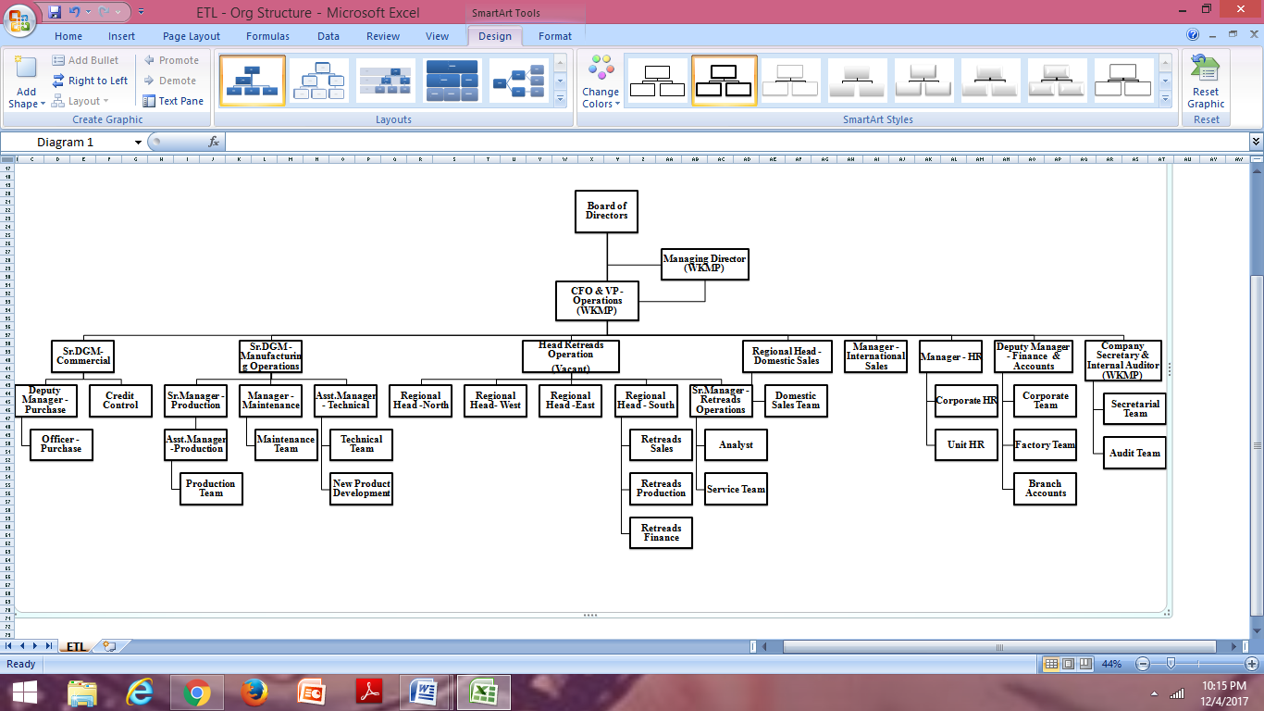

**2.SYSTEM ANALYSIS**

**2. SYSTEM ANALYSIS**

The “**Eastern Treads Management System**” gives us the complete information about the operations handled in a tyre company. We can enter the details of the company and maintain their records in the Database.

The software provides a user friendly interface which can be operated by anyone with a minimum knowledge of the computer system. It stores the information needed by the company in a data base which can be accessed by the administrator within the organization. In the required system all the operations and activities related to the retreading company should be carried out efficiently. It should maintain a well-organized database for storing the resources that are provided by the company. This helps us to eliminate the entering of invalid data. Most problems of manual system can be solved by this required system. The system should cover almost all the functional areas of the retreading company .The “**Eastern Treads Management System**” should be a database system that can store the information regarding keeping record of all the details vehicle category, customers, repair patches etc.

System Analysis refers to the process of examining a situation with the intention of improving it through better process and methods. System analysis is therefore, the process of gathering and interpreting facts, diagnosing problem and using the information to recommend information in system or in other words, it means a detailed explanation or description. Before computerizing a system under consideration, it has to be analyzed. We need to study how it functions currently, what are problems and what are requirements that proposed software should meet.

The main components of making software are:

• System and software requirements analysis

•Design and implementation of software

•Ensuring, verifying and maintaining software integrity

**2.1 PROBLEM ANALYSIS**

The first steps in the initial investigation are directed towards clarifying the problems of the existing system. Based on the initial investigation about the existing system it is found that most of the activities taking place in the tread companies are less automated and much of the activities involve a lot of human work such manual entry of details such as category,pattern,sale, payment etc. The existing database for storing these details like staffs, category, pattern,sale etc and all are not that efficient and are not flexible. Updating and maintenance is cumbersome. Searching for a particular entry or a record is a bit time consuming task. In the existing system it is noticed that the operations which are automated are not fully centralized to the administrator. Many users are having access to the database. Thus it provides less security for the data being stored in the database.

It then study the problem areas to find what all modification is has to be overseen in the new system. The aids which I have used during the requirement analysis are mainly questionnaires and conducting personal interviews .Most of the data is being collected by direct personal meetings with the staffs and administrator of the company for which the proposed system is being developed.

The proposed system is thus overseeing all these issues so as to make the transactions and recording of other details such as order, suppliers etc. within the organization more efficient and more secure.

**2.1.1 EXISTING SYSTEM**

The existing system uses manual method for the whole process such manual entry of details such as staffs, tread types, tyre types, etc. This requires a lot of hard work and time consumption to complete the task. This may include human errors. In the existing system, it is difficult to retrieve some particular information. Also, all the records are stored manually and it is a tedious task. As a result the security of these records is always a challenging task. In spite of all the efforts undertaken, the destruction of data may happen often. Hence, the computerization of the system of record maintenance is the only solution to reduce the shortcomings of the existing system

. There are many disadvantages in manual system:

* **Inaccuracies:**

Since all the data entry is done manually, inaccuracies can occur. Cause of error is more in manual system.

* **Modification:**

The transactions are executed in off-line mode, hence on-line data capture and modification is not possible.

* **Expensive:**

The maintenance of this project can be expensive.

Large number of personal hours is required for each and every part of the manual system. We have to buy lot of books, paper for keeping the information. So the existing system is very expensive.

* **Inefficiency:**

The existing system only provides text-based interface, which is not as user-friendly as Graphical user Interface. Inefficiency in the existing system is also caused by the lack of proper communication between the people of the organization.

* **Time and effort:**

Large amount of time and efforts may require. For searching a particular data, we have to search all the paper documents, its corresponding book and find the data.

* **All the searching are done manually:**

In the existing system, all the work like entering the staff details, customer details, payment details etc. is done manually. This is really time consuming.

**2.1.2 PROPOSED SYSTEM**

The proposed system is interactive, highly user friendly and designed exclusively for the “**Eastern** **Treads Management System**”. The system covers almost all the functional areas of the “**Eastern** **Treads Management System**” such as details of staffs, salaries, tyre types, customers, retreading sales etc.

All the operations and activities related to the “**Eastern Treads Management System**” can be carried out efficiently. The project maintains well organized database for storing the resources that they are provided by the client. This helps us to eliminate the entering of invalid data. Most problems of manual system can be solved by this system.

The computerization of the system allows the easy maintenance of the details. Large amount of data can be stored easily. Addition and updating other changes can be done easily. The information can be retrieved with high speed and accuracy. The use of GUI oriented software makes the system user friendly. Since all work is computerized, the calculations are effortless and less time consuming. Speed, accuracy, storage capacity, versatility, automation etc. are the advantages of using a computerized system.

The main purpose behind the proposed system is to provide a comprehensive computerized system, which can capture, collate and analyze the data from these wards and evaluate the impact of the program.

The main advantages of the new system are:

* **Security:**

The software used for this “Eastern Threads Management System” includes the password, so the security is provided. When anyone opens the software it has the provision for entering password. We have to enter the correct password; otherwise we cannot enter into the system. Password is saved in system registry for more security.

* **User Friendly:**

This package is very user friendly because it is easy to maintain and operate. All data entry operations are simple, administrator needs only to enter data and all other operations are performed by the computer.

* **Speed and Accuracy:**

Computerization process increases the speed of all the operations. The manpower is reduced. Instead of doing all operation manually, computer will do it automatically. It also increases the accuracy of all the operations performed.

* **Efficiency and flexibility:**

The flexibility and the efficiency of all the operation in the company is increased because of the computerization. No errors are occurred compared to the manual system

## Automation: The proposed system automates each and every activity of the manual system and increases its throughput. Thus the response time of the system is very less and it works very fast.

**2.1.3 FEASIBILITY STUDY**

The “**Eastern Treads Management System**” is a software package which provides guidance for all the retreading company purpose. This project will provide for computerization of a small enterprise whose main goal is to keep the details of category, staffs, customers, tyre types etc and wants to change from paper based transaction to computerized transaction.

Feasibility study is test of system proposal according to its workability, impact on organization, ability to meet the needs, effective use of resources. During the study, the problem definition is crystallized and aspects of the problem to be included in this system are determined. The result of the feasibility study is a formal proposal. If the proposal is accepted, we continue with the project.

User needs a data-based system, which will remove all the mentioned problems that, the user is facing. The user wants a data-based system, which will reduce the bulk of paper work, provide ease of work, flexibility, fast record finding, modifying, adding, and removing.

We proposed our perception of the system, in accordance with the problems of existing system by making a full layout of the system on paper. We tallied the problems and needs by existing system and requirements. We were further updating in the layout in the basis of redefined the problems. In feasibility study phase we had undergone through various steps, which are described as under:

* Cost:

The cost required in the proposed system is comparatively less to the existing system.

* Effort:

Compared to the existing system the proposed system will provide a better working environment in which there will be ease of work and the effort required will be comparatively less than the existing system.

* Time:

Record finding and updating will take less time than the existing system.

* Labor:

In the existing system the number of staff required for completing the work is more while the new system will require quite less number of staff.

2.1.3.1 ECONOMICAL FEASIBILITY

The proposed system “**Eastern Treads Management System**” is economically feasible one. We do not want to keep lot of books for storing the data. By manipulating data using computer reduces cost. We do not want lot of employees; we simply want one to operate it, Administrator.

Economic analysis is most frequently used method for evaluating the effectiveness of a candidate system. More commonly known as cost/benefit analysis, the procedure is to determine the benefits and savings that are expected from a candidate system and compare them with costs.

In my project I make use of the existing systems which have visual Basic 6.0 installed on them along with the database which is SQL Server 2008. Though the cost of buying SQL Server is often high, once it is bought, there is no other maintenance cost and we are not buying any other software especially for this project, so we can say that the project is economically feasible.

The only possible fixed costs involved with the system would be paying for people to write the code. It is possible if students would be willing to work on it as a project. There are no variable costs associated with this system- since it operates on the servers, the department does not pay anything for each use of the system. The tangible benefits will mostly be in time savings for the current administrators, as well as a simplified process for activities. The intangible benefits would be increased system involvement among staff and decreased workload on the current administrators.

2.1.3.2 TECHNICAL FEASIBILITY

The project “**Eastern Treads Management System**” can be said to be technically feasible because there will be less number of errors actually no errors because the whole project will be divided into modules and so the errors if found, can be debugged very well and all the bugs can be removed.

Technical feasibility centres on the existing computer system and to what extend it can support the proposed system. It involves financial considerations to accommodate technical enhancements. If the budget is a serious constraint, then the project is judged not feasible. Here we need only a computer working in low speed to accomplish the task.

Since the system uses database to implement, it is technically practical for all operators. The system can be implemented on the servers that the department currently has access too. The system requires no special expertise to operate, although some expertise will be required to code it.

**2.1.3.3 BEHAVIORAL FEASIBILITY**

The proposed system “**Eastern Treads Management System**” can be easily accepted as it is very easy to understand and is very user-friendly. The operations and other features of the proposed system is designed in such a way that the user can easily find the datas, insert the datas etc. The organization will not be disturbed by the use of this system because, the users will be provided with prompts which will enable them to use this software very easily.

People are inherently resistant to change and computer has been known to facilitate changes. An estimate should be made of how strong the user is likely to move towards the development of computerized system. These are various levels of users in order to ensure proper authentication and authorization and security of sensitive data of the organization. Therefore it is understandable that the introduction of a candidate system requires special efforts to educate and train the staff. The software that is being developed is user friendly and easy to learn. In this way, the developed software is truly efficient and can work on any circumstances, tradition, locales. Operational study strives on ensuring that the equilibrium of the organization and status quo in the organization neither are nor disturbed and changes are readily accepted by the users.

**2.2 REQUIREMENT SPECIFICATION**

The “**Eastern Treads Management System**” software deals with the recording details of staffs, customers, vehicle type, categories etc .All these details are computerized. This also minimizes the duplication of entries made by the administrator. It also reduces the search time. The software provides a user-friendly interface which can be operated by anyone with a minimum knowledge of computer system.

In the required system all the operations and activities related to “**Eastern Treads Management System**” should be carried out efficiently. It should maintain a well-organized database for storing the resources that are provided by the “**Eastern Treads Management System**” .This helps us to eliminate the entering of invalid data. Most problems of manual system can be solved by this required system. The system should cover almost all the functional areas of the “**Eastern Treads Management System**” .The “**Eastern Treads Management System**” should be a database system that can store the information regarding staffs, tread types, tyre types, repair patches etc.

The “**Eastern Treads Management System**” is software package which provides guidance for all the “Eastern Treads Management System”. This project will provide for computerization of small enterprise whose main goal is to keep track on their sales details and wants to change from paper based data entry to computerized data entry.

The “**Eastern Treads Management System**” software will make storing of the details such as staff, customer, category, patches, tyre details etc easier.

A requirement definition is a statement, in a natural language plus diagrams, of what services the system is expected to provide and the constraints under which it must operate. It is generated using Members-supplied information

The following represents the requirement definition of the system:

• The software must contain all the details about the tyre.

• The software also provides administrator facility for adding new Staff and customer etc

•The administrator should have the rights for overall management.

**2.2.1 SOFTWARE REQUIREMENT AND SPECIFICATION**

An SRS is basically an organization’s understanding (in writing) of a customer or potential client’s system requirements and dependencies at a particular point in time (usually) prior to any actual design or development work. It’s a two way insurance policy that assures that both the client and the organization understand the others requirements from that perspective at a given point in time.

Software requirements for the “**Eastern Treads Management System**” software deals with the recording details of staffs, customers, tread types etc .All these details are needed to computerized. This should also minimize the duplication of entries made by the administrator.

A required specification is a structured document, which sets out the system services in detail. This document, also called a functional specification, which should be precise. It may serve as a contract between the system buyer and the software developer. The requirement specification defines the basic specifications of the user for the new system.

The software required for developing the “**Eastern Treads Management System**” are Windows 7 as Os, Visual basic 6.0 as front end for designing GUI, SQL server 2008 for data storage.

• The administrator should get the supreme authority over the database and all the processes

• Each user should have unique identification.

• The system should be able to provide simple and complete details of customer and their billing details.

• Username and password are given by the administrator.

The SRS document itself states in precise and explicit language those functions and capabilities a software system must provide, as well as states any required constraints by which the system must abide. The SRS also functions as a blueprint for completing a project with as little cost growth as possible. The SRS is often referred to as “parent” document because all subsequent project management documents, such as design specifications, statement of works, software architecture specifications, testing and validation plans, and documentation plans , are related to it.

It’s important to note that an SRS contains functional and non-functional requirements only; it doesn’t offer design suggestion, possible solutions to technology or business issues, or any other information other than what the development team understands the customer system requirement to be.

Functional requirements of the “**Eastern Treads Management System**” are:

* The system should provide required outputs under any conditions.Billing of customers should be accurate.
* Only administrator should be allowed to access database.
* The admin and staff can login only through user name and passwords.

Non Functional requirements of the system are reliability,portability and performance. “**Eastern Treads** **Management System**” mainly focuses on the reliability,security and time. This system will provide with the reliability that the user expects. It reduces the time consumed when compared to manual system. The data will be stored securely.

A well designed, well written SRS accomplishes four major goals:

* It provides feedback to the customer. An SRS is the customer’s assurance that the development organization understands the issues or problems to be solved and the software behavior necessary to address problems. Therefore, the SRS should be written in natural language in an unambiguous manner that may also include charts, tables, data flow diagrams, and decision tables and so on.
* It decomposes the problem into component parts. The simple act of writing down software requirements in a well-designed format organizes information, places borders around the problem, solidifies ideas, and helps break down the problem into its component parts in an orderly fashion.
* It serves as an input to the design specification. As mentioned previously, the SRS serves as the parent document to subsequent documents, such as the software design specification and statement of work. Therefore, the SRS must contain sufficient detail in the functional system requirement so that a design solution can be devised.
* It serves as a product validation check. The SRS also serve as the parent document for testing and validation strategies that will be applied to the requirements for verification.

## 2.3 HARDWARE AND SOFTWARE SELECTION AND JUSTIFICATION

**HARDWARE SPECIFICATION**

The selection of hardware is very important in the existence and proper working of any software. When selecting hardware, the size and capacity requirements are also important. Below is some of the hardware that is required by the system

Processor : Single core processor of 2.0 GHz or more

RAM : 512 MB of RAM

Hard Disk Space : 300 MB free hard disk space

Input Devices : Mouse, Keyboard

Output Devices : Monitor, Printer

**SOFTWARE SELECTION AND JUSTIFICATION**

We require much different software to make the application which is in making to work efficiently. It is very important to select the appropriate software so that the software works properly.

Below are the software that are required to make the new system.

1. Windows XP or higher versions

2. SQL Server Management Server 2008

3. Visual Basic 6.0

**WINDOWS 7**

**Windows7** (codenamed **Vienna**,formerly **Blackcomb**)is apersonalcomputer [operating system](https://en.wikipedia.org/wiki/Operating_system) developed by [Microsoft](https://en.wikipedia.org/wiki/Microsoft). It is a part of the [Windows NT](https://en.wikipedia.org/wiki/Windows_NT) family of operating systems. Windows 7 was [released to manufacturing](https://en.wikipedia.org/wiki/Software_release_life_cycle#Release_to_manufacturing_.28RTM.29) on July 22, 2009, and became generally available on October 22, 2009, less than three years after the release of its predecessor, [Windows Vista](https://en.wikipedia.org/wiki/Windows_Vista). Windows 7's [server](https://en.wikipedia.org/wiki/Server_(computing)) counterpart, [Windows Server 2008 R2](https://en.wikipedia.org/wiki/Windows_Server_2008_R2), was released at the same time.

Windows 7 was primarily intended to be an incremental upgrade to the operating system intending to address Windows Vista's poor critical reception while maintaining hardware and software compatibility. Windows 7 continued improvements on [Windows Aero](https://en.wikipedia.org/wiki/Windows_Aero) (the [user interface](https://en.wikipedia.org/wiki/User_interface) introduced in Windows Vista) with the addition of a redesigned [taskbar](https://en.wikipedia.org/wiki/Taskbar) that allows applications to be "pinned" to it, and new window management features. Other new features were added to the operating system, including libraries, the new file sharing system HomeGroup, and support for [multitouch](https://en.wikipedia.org/wiki/Multitouch) input. A new "Action Center" interface was also added to provide an overview of system security and maintenance information, and tweaks were made to the [User Account Control](https://en.wikipedia.org/wiki/User_Account_Control) system to make it less intrusive. Windows 7 also shipped with updated versions of several stock applications, including[Internet Explorer 8](https://en.wikipedia.org/wiki/Internet_Explorer_8), [Windows Media Player](https://en.wikipedia.org/wiki/Windows_Media_Player), and [Windows Media Center](https://en.wikipedia.org/wiki/Windows_Media_Center).

**Visual Basic 6.0**

**Visual Basic** is a [third-generation](https://en.wikipedia.org/wiki/Third-generation_programming_language) [event-driven programming language](https://en.wikipedia.org/wiki/Event-driven_programming) and [integrated development environment](https://en.wikipedia.org/wiki/Integrated_development_environment) (IDE) from [Microsoft](https://en.wikipedia.org/wiki/Microsoft) for its [COM](https://en.wikipedia.org/wiki/Component_Object_Model) programming model first released in 1991 and declared legacy in 2008. Microsoft intended Visual Basic to be relatively easy to learn and use. Visual Basic was derived from [BASIC](https://en.wikipedia.org/wiki/BASIC) and enables the [rapid application development (RAD)](https://en.wikipedia.org/wiki/Rapid_application_development) of [graphical user interface (GUI)](https://en.wikipedia.org/wiki/Graphical_user_interface)applications, access to [databases](https://en.wikipedia.org/wiki/Database) using [Data Access Objects](https://en.wikipedia.org/wiki/Data_Access_Object), [Remote Data Objects](https://en.wikipedia.org/wiki/Remote_Data_Objects), or [ActiveX Data Objects](https://en.wikipedia.org/wiki/ActiveX_Data_Object), and creation of [ActiveX](https://en.wikipedia.org/wiki/ActiveX) controls and objects.

A programmer can create an application using the [components](https://en.wikipedia.org/wiki/Component-based_software_engineering) provided by the Visual Basic program itself. Over time the community of programmers developed third party components. Programs written in Visual Basic can also use the [Windows API](https://en.wikipedia.org/wiki/Windows_API), which requires external function declarations.

The final release was version 6 in 1998 (now known simply as Visual Basic). On April 8, 2008 Microsoft stopped supporting Visual Basic 6.0[IDE](https://en.wikipedia.org/wiki/Integrated_development_environment). The Microsoft Visual Basic team still maintains compatibility for Visual Basic 6.0 applications on [Windows Vista](https://en.wikipedia.org/wiki/Windows_Vista), [Windows Server 2008](https://en.wikipedia.org/wiki/Windows_Server_2008) including R2, [Windows 7](https://en.wikipedia.org/wiki/Windows_7), [Windows 8](https://en.wikipedia.org/wiki/Windows_8), [Windows 8.1](https://en.wikipedia.org/wiki/Windows_8.1), [Windows Server 2012](https://en.wikipedia.org/wiki/Windows_Server_2012) and [Windows 10](https://en.wikipedia.org/wiki/Windows_10) through its "It Just Works" program. In 2014, some [software developers](https://en.wikipedia.org/wiki/Software_developer) still preferred Visual Basic 6.0 over its successor, [Visual Basic .NET](https://en.wikipedia.org/wiki/Visual_Basic_.NET). In 2014 some developers lobbied for a new version of Visual Basic 6.0. In 2016, Visual Basic 6.0 won the technical impact award at The 19th Annual D.I.C.E. Awards. A dialect of Visual Basic, [Visual Basic for Applications](https://en.wikipedia.org/wiki/Visual_Basic_for_Applications) (VBA), is used as a macro or scripting language within several Microsoft applications, including [Microsoft Office](https://en.wikipedia.org/wiki/Microsoft_Office)

**SQL Server 2008**

SQL Server 2008 was released on August 6, 2008, announced to the SQL Server Special Interest Group at the ESRI 2008 User's Conference on August 6, 2008 by Ed Katibah and aims to make data management [self-tuning](https://en.wikipedia.org/wiki/Self-tuning), self organizing, and self maintaining with the development of SQL Server Always On technologies, to provide near-zero downtime. SQL Server 2008 also includes support for [structured](https://en.wikipedia.org/wiki/Structured_data) and semi-structured data, including digital media formats for pictures, audio, video and other multimedia data. In current versions, such multimedia data can be stored as [BLOBs](https://en.wikipedia.org/wiki/Binary_large_object) (binary large objects), but they are generic bit streams. Intrinsic awareness of multimedia data will allow specialized functions to be performed on them. According to [Paul Flessner](https://en.wikipedia.org/w/index.php?title=Paul_Flessner&action=edit&redlink=1), senior Vice President of Server Applications at Microsoft, SQL Server 2008 can be a data storage backend for different varieties of data: XML, email, time/calendar, file, document, spatial, etc. as well as perform search, query, analysis, sharing, and synchronization across all data types.

**2.4 USE CASE DIAGRAM**

**ADMIN STAFF**

**2.5 DATA FLOW DIAGRAM**

A DFD also known as ‘bubble chart’ has the purpose of clarifying system requirements and identifying major transformations. It shows the flow of data through a system. It is a graphical tool because it presents a picture. The DFD may be partitioned into levels that represent increasing information flow and functional detail. Four simple notations are used to complete a DFD. These notations are given below:-

**DATA FLOW**

The data flow is used to describe the movement of information from one part of the system to another part. Flows represent data in motion. It is a pipe line through which information flows. Data flow is represented by an arrow.

**PROCESS**

A circle or bubble represents a process that transforms incoming data to outgoing data. Process shows a part of the system that transforms inputs to outputs.

**EXTERNAL ENTITY**

A square defines a source or destination of system data. External entities represent any entity that supplies or receive information from the system but is not a part of the system.

**DATA STORE**

The data store represents a logical file. A logical file can represent either a data store symbol which can represent either a data structure or a physical file on disk. The data store is used to collect data at rest or a temporary repository of data. It is represented by open rectangle.

**2.5.1 CONTEXT LEVEL DIAGRAM**

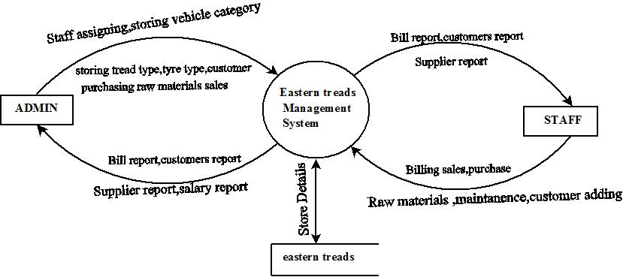

**2.5.2 FIRST LEVEL DATAFLOW DIAGRAM**

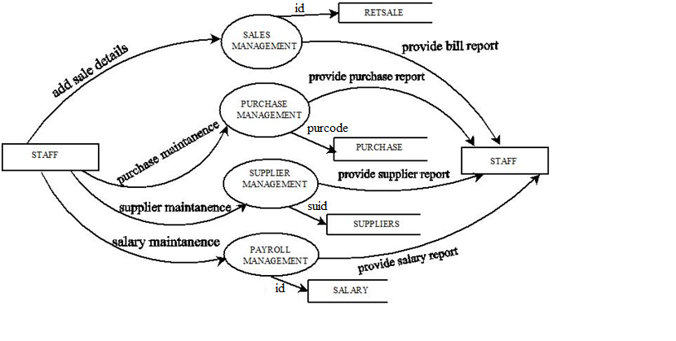

**ADMIN**

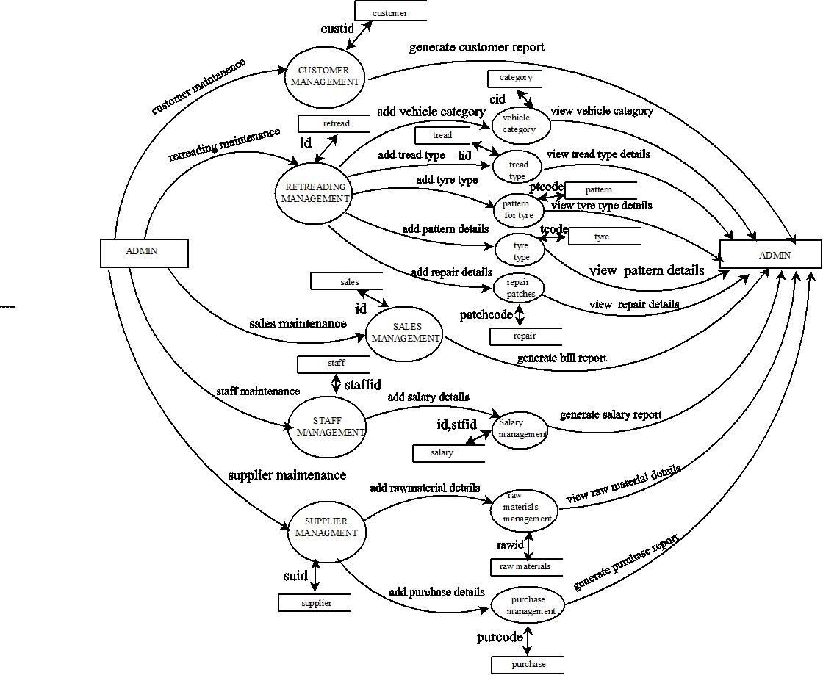

**ER DIAGRAM**

**Vehicle category**

**Customer**

**includes**

**Request**

**involv**e

**include**s

**Payment**

**Pattern**

**Sale**

**include**

**has**

**has**

**Tread Type**

**Tyre type**

**contain**

**Subpattern**

**has**

**Repair Patches**

**Patch Product**

**3. SYSTEM DESIGN**

**3. SYSTEM DESIGN**

The “**Eastern Treads Management System**” is being developed to record the details of staffs, customers, tyre types, vehicle category etc. System design is the process of defining the architecture, components, modules, interfaces and data for a system to satisfy specified requirements. It is a solution to a “how to” approach compared to system analysis which is a “what is” orientation. It translates the system requirements into ways of making them operational.

The system is being designed in such a way that all the operations handled in the company is easily maintained and can be used by any retreading company to automate the system. Presently the records are not computerized and require more manpower.

After analyzing the existing system in detail and identified the problem areas and alternative solutions have been studied the next step is design the system that is selected after the analysis conducted during the study phase. The design phase focuses on the detailed implementation of the system recommended in the feasibility study. The proposed system overcomes the existing system problems.

The system which is in making is developed by working on one module and work as a single unit. That single unit is the one which is known as the new software. We go through the different design strategies to design the system we are talking about. In the input design we decide which type of input screens are going to be used for the system in making. In the output design we decide the output screens and the tables that will be used to give the output and in the database design we decide what all tables will be required and what all fields will be there in those tables.

**3.1 STRUCTURED DESIGN METHODOLOGIES**

Design methodology refers to the development of a system or method for a unique situation. Design methodology stresses the use of brainstorming to encourage innovative ideas and collaborative thinking to work through each proposed idea and arrive at the best solution. Meeting the needs and requirements of the end user is the most critical concern. To employ design methodology various analyses and testing have been done so as to meet the desired user needs. Every input that the user input is being tested in this software. That means the validity of each data is being checked and if found invalid necessary warning and prompting messages are displayed. The output forms are also tested in detail to see whether the desired output is met or not. Also the output forms are made more clear and meaningful for the user to understand.

**3.2 USER INTERFACE DESIGN**

User interface design is one of the major functions in developing a system. It is a good understanding of the user needs very clearly. Because the user is the person who has to interact with system being developed. So that it should seek the needs of the user before developing it. The system is designed in a very user friendly manner that makes the user with little knowledge of computer and of the organization can work very easily with the system.

The input forms that are used to enter the data are made more clear and easy to understand. Every time the user enters data the system is designed to check the validity of the data and if found as invalid meaningful prompting and warning messages are displayed. This makes the user comfortable to interact with the system.

Also when a user login to the system it checks the username and password entered to see whether it is valid user or not. It ensures security of the system and database. The data storage and data processing are made more efficient so that accurate results are being displayed on the output forms. And also the retrieval of specific records as demanded by the user is made very faster that saves the user time. The input forms for the project is given in Appendix B for reference.

Main Input Forms are as Follows:-

**Login:** This form is used to enter the details of login. The details include username and password

**Customer :** This form is used to include details of customer which include name,address,phone,email id etc.

**sales:**this form includes the billing details.the details include the customer name,tread type,tyre type,pattrns,quantity,amount etc.

**3.3 OUTPUT DESIGN**

Output design is used to provide outputs to the users of the system. Computer output is the most important direct source of information to the user. Efficient intelligible output design improves the system relationships with the user and help in decision making major form of the output is the hardcopy from the printer and the screen reports. The output devices to consider depend on factors such as compatibility of the devices with the system, expected print quality and number of copies needed.

Here, in this case, I make use of forms which contains the tables to show the outputs of the processed data. The output design has been done so that the results of processing should be communicated to the user. Effective output design will improve the clarity and performance of outputs. Output is the main reason for developing the system and the basis on which they will evaluate the usefulness of the application. Output design phase of the system is concerned with the Convergence of information to the end user in a friendly manner. The output design should be efficient, intelligible so that system relationship with the end user is improved and thereby enhancing the process of decision making. The output forms for the project are given in Appendix B for reference.

The major output forms are as follows:

**Bill:**

This form generates the bill details of the customer.this details include bill no,customer id.

The major output reports are as follows

**Salary report:**

This report shows the salary details of the staffs which includes the staff id,month no,no of leaves and the total salary.

**Bill report:**

This report shows the details of the bill that paid on a particular date.the details include in his report are bill no , amount paid,customer id etc.

The reports for the project is given in Appendix C for reference.

**3.4 DATABASE DESIGN**

A database is a collection of interrelated data stored within minimum redundancy to serve many users quickly and efficiently. It is a process of designing the database file, which is the key source of the information in the system. The objective of database is to design is to provide storage and it contributes to the overall efficiency of the system. The file should properly design and planned for collection, accumulation, editing and retrieving the required information.

**TABLE DESIGN**

**Table no:1**

category: The table contains data about the vehicle category such as categoryid, category name.

Primary key: cid

|  |  |  |
| --- | --- | --- |
| Field | Datatype | Description |
| cid | Varchar(50) | Vehicle category id |
| Cname | Varchar(50) | Vehicle category name |

**Table no:2**

Login: The table contains data about the login information such as username, password, usertype,

Primary Key: username

|  |  |  |
| --- | --- | --- |
| Field | Datatype | Description |
| Username | Varchar(50) | Username |
| Password | Varchar(50) | Password |
| Usertype | Varchar(50) | Usertype |

**Table no:3**

Patchproduct: The table contains data about the patch product such as patchcode, productcode, unitbox, inches,mm,tyresize.

Primary key: procode

Foreign Key: patchcode

|  |  |  |
| --- | --- | --- |
| Field | Datatype | Description |
| Patchcode | Varchar(50) | Patchcode |
| Procode | Varchar(50) | Productcode |
| Unitbox | Varchar(50) | Unitbox |
| Inches | Varchar(50) | Inches |
| Mm | Varchar(50) | Mm |

**Table no:4**

Pattern: The table contains data about the pattern such as patterncode,patternname, vehicletype, tyretype, treadtype and amount

Primary key: ptcode

|  |  |  |
| --- | --- | --- |
| Field | Datatype | Description |
| Ptcode | Varchar(50) | Connection id |
| Contype | Varchar(15) | Connection type |
| Consno | Varchar(15) | Consumer id |
| Location | Varchar(15) | Location of consumer |
| Conpower | Varchar(15) | Power type |
| Condate | Varchar(15) | Connection date |
| Charge | Int | Charge of connection |

**Table no:5**

Customer: The table contains data about the customer such as name, customerid, address, mail id, contact number and customertype.

Primary key: custid

|  |  |  |
| --- | --- | --- |
| Field | Datatype | Description |
| Custid | Varchar(15) | Consumer id |
| Custname | Varchar(15) | Consumer name |
| Addr | Varchar(15) | Consumer address line 1 |
| City | Varchar(15) | City |
| Pin | Int | Pin code of customer |
| Email | Varchar(15) | Mail id |
| Custtype | Varchar(15) | Category of consumer |

**Table no:6**

payment: The table contains data about the bill such as billno,date,sales id and amount

Primary key: billno

|  |  |  |
| --- | --- | --- |
| Field | Datatype | Description |
| Billno | varchar(50) | Bill no |
| Date | varchar(50) | Date of the bill produced |
| Sid | varchar(50) | Sales id |
| Amt | Int | Amount to be paid |

**Table no:7**

purchase: The table contains data about the purchase details of rawmaterials such as purchase code, purchase date, rawmaterial name,supplier code,quantity.

Primary key:purcode

Foreign Key: supcode

|  |  |  |
| --- | --- | --- |
| Field | Datatype | Description |
| Purcode | varchar(50) | Purchase code |
| Date | Date | Purchase date |
| Rawmatname | varchar(50) | Rawmaterial name |
| Supcode | varchar(50) | Supplier code |
| Qty | Int | Quantity |

**Table no:8**

Employee: The table contains data rawmaterial such as rawmaterial id,rawmaterial name.

Primary key: rawid

|  |  |  |
| --- | --- | --- |
| Field | Datatype | Description |
| Rawid | varchar(50) | Rawmaterial id |
| Rawname | varchar(50) | Rawmaterial name |
| Descript | varchar(50) | Description |

**Table9:**

Repair : The table contain the details of repair patches such as patchcode,patchname,tyretype.

Primary key:patchcode

|  |  |  |
| --- | --- | --- |
| Field | Datatype | Description |
| Patchcode | varchar(50) | Patchcode |
| Patchname | varchar(50) | Patchname |
| Tyrtyp | varchar(50) | Tyretype |

**Table10:**

Retsale: the table contains the details of the retreadind sales such as id,date,customer id,product deliverydate,totalamout.

Primary key:id

Foreign key:custid

|  |  |  |
| --- | --- | --- |
| Field | Datatype | Description |
| Id | varchar(50) | Sales id |
| Dte | varchar(50) | Sales date |
| Custid | varchar(50) | Customer id |
| Prodate | varchar(50) | Product delivery date |
| Tamt | Int | Total amount |

**Table 11:**

Salesitem:the table contain the details od the sales of the item such as sales id,treadtype,tyretype, patterncode,quantity,amount.

Primary key:sid

|  |  |  |
| --- | --- | --- |
| Field | Datatype | Description |
| Sid | varchar(50) | Sales id |
| Trtyp | varchar(50) | Tread type |
| Tytyp | varchar(50) | Tyre type |
| Patcode | varchar(50) | Pattern code |
| Qty | Int | Quantity |
| Amt | Int | Amount |

**Table12:**

Subpattern :the table contains the values of subpattern such as subpattern code ,patterncode, basewidth, treaddepth,basethickness,length,weight.

Primarykey: supatcode

Forign key:patcode

|  |  |  |
| --- | --- | --- |
| Field | Datatype | Description |
| Patcode | varchar(50) | Pattern code |
| Supatcode | varchar(50) | Subpattern code |
| Basewidth | varchar(50) | Basewidth |
| Treaddepth | varchar(50) | Tread depth |
| Basethick | varchar(50) | Base thickness |
| Length | varchar(50) | Length |
| Weight | varchar(50) | Weight |

**Table13 :**

Suppliers :the table contain the details of suppliers such as supplier id,supplier name,address,phone no.

Primary key:suid

|  |  |  |
| --- | --- | --- |
| Field | Datatype | Description |
| Suid | varchar(50) | Supplier id |
| suname | varchar(50) | Supplier name |
| addres | varchar(50) | Address |
| Pno | varchar(50) | Phone number |

**Table14:**

Tread:the table contain the details of the retreading type such as treadtype and tread name.

Primary key:tid

|  |  |  |
| --- | --- | --- |
| Field | Datatype | Description |
| Tid | varchar(50) | Tread id |
| Tname | varchar(50) | Tread name |

**Table 15:**

Tyre:the table contain the details of tyres such as tyrecode,tyretype,tyreside, treadtype,tyresize.

Primary key:tcode

|  |  |  |
| --- | --- | --- |
| Field | Datatype | Description |
| Tcode | varchar(50) | Tyre code |
| Ttype | varchar(50) | Tyre type |
| Tside | varchar(50) | Tyre side |
| Treadtype | varchar(50) | Tread type |
| Tsize | varchar(50) | Tyre size |

**Table 16:**

staff: the table contain the details of staff

primary key:staffid

|  |  |  |
| --- | --- | --- |
| Field | Datatype | Description |
| Staffid | varchar(50) | Staff id |
| Staffname | varchar(50) | Staff name |
| Desig | varchar(50) | Designation |
| Gender | varchar(50) | Gender |
| Email | varchar(50) | Email |
| Dob | Date | Date of birth |
| Addre | varchar(50) | Address |
| Phone | varchar(50) | Phone number |
| Quali | varchar(50) | Qualification |
| Accno | varchar(50) | Account number |
| Salary | Int | Salary |
| Joiningdate | Date | Joiningdate |

**Table17:**

Salary:the salary table consist of the salary details of each staff

Primary key:id

Foreign key:stid

|  |  |  |
| --- | --- | --- |
| Field | Datatype | Description |
| Id | Int | Salary slip id |
| Stfid | varchar(50) | Staff id |
| Mnth | varchar(50) | Month |
| Npay | Int | Netpay |

**3.4.1 DATA & INTEGRITY CONSTRAINTS**

The primary objective of a database design are fast response time to inquiries ,more information at low cost, control of redundancy, clarity and ease of use, accuracy and integrity of the system, fast recovery and availability of powerful end-user languages. The theme behind a database is to handle information as an integrated whole thus the main objective is to make information as access easy, quick, inexpensive and flexible for the users. In this project, we mainly concentrated into relational databases.

Relational database stores data in tables, which is turn, are composed of rows also known as records, columns also known as fields. The fields in the relational model are:-

**Primary Key**

The key which is uniquely identify records. They also notify the not null constraints.

**Foreign Key**

The key which reference the primary key, is the data inserted in the primary key column of the table.

**Normalization**

After the conceptual level, the next level of process of database design to organize the database structure into a good shape called Normalization. The normalization simplifies the entries, removing redundancies from the system data and finally builds a data structure, which is both flexible and adaptable to the system. The different normal forms obtained during the database design are given below:

In the database design, we create a database with different tables that is used to store the data. We normalize the data in the table. **Database normalization** is the process of organizing the fields and tables in a relational database to minimize redundancy and dependency. Normalization usually involves dividing large tables into smaller (and less redundant) tables and defining relationships between them. The objective is to isolate data so that additions, deletions, and modifications of a field can be made in just one table and then propagated through the rest of the database via the defined relationships.

In the project I have made used of the 3rd normal form, Third Normal Form (3NF) is a property of database tables. A relation is in third normal form if it is in Second Normal Form and there are no functional (transitive) dependencies between two (or more) non-primary key attributes. The overall objective in the development of database technology has been to treat data as an organizational resource and as an integrated whole. Database Management System allows data to be protected and organized separately from other resources. Database is an integrated collection of data. This is the difference between logical and physical data.

In my project, I have made use of tables which are stored in the database named easterntreads. The tables are used to store the values that are generated by the application. The main field names and the key constraints of all the tables are shown above in detail.

**4. CODING**

**4.CODING**

**PROGRAM CODE PREPARATION**

When considered as a step in software engineering, coding is viewed as a natural consequence of design. However, programming language characteristics and coding style can profoundly affect software quality and maintainability. The coding step translates a detail design representation into a programming language realization. The translation process continues when a compiler accepts source code as input and produces machine-independent object code as output. The initial translation step in detail design to programming language is a primary concern in the software engineering context. Improper interpretation of a detail design specification can lead to erroneous source code. Style is an important attribute of source code and can determine the intelligibility of a program. The elements of a style include internal documentation, methods for data declaration, procedures for statement construction, and I/O coding and declaration. In all cases, simplicity and clarity are key characteristics. An offshoot of coding style is the execution time and/or memory efficiency that is achieved. Coding is the phase in which we actually write programs using a programming language. In the coding phase, design must be translated into a machine readable form. If design is performed in a detailed manner, coding can be accomplished mechanistically. It was the only recognized development phase in early or unsystematic development processes, but it is just one of several phases in a waterfall process. The output of this phase is an implemented and tested collection of modules.

In my project I have made use of the visual Basic 6.0 to code the whole project and have made use of the SQL Server 2008 to act as a database to store the results of the processed data which is the output of the project.

The codings for the project is given in Appendix A for reference.

**5. IMPLEMENTATION OF SECURITY**

**5. IMPLEMENTATION OF SECURITY**

The software quality assurance is comprised of a variety of tasks associated with seven major activities.

* Application of technical methods
* Conduct of formal technical reviews.
* Software testing.
* Enforcement of standards.
* Record keeping and reporting.

The quality begins with a set of technical methods and tools that help the analyst to achieve high quality specification and the designer to develop high quality design. The next activity involves assessment for quality for the design that is created which is the formal technical review. Software testing combines a multi-step strategy with a series of test case design methods that help ensure effective error detection.

**5.1 DATA SECURITY**

The software maintains a well organized database for storing the details that are provided by the user. This helps us to eliminate the entering of invalid data. Data is not accessible to unauthorized users. The system analyst will provide the test data, specially designed to show that the system will operate successfully in all its aspects and produce expected results under expected conditions. Preparation of test data and the checking of results should be carried out in conjunction with the appropriate users and operational departments. Also the extent to which the system should be tested must be planned.

**5.2 USER AND ACCESS RIGHTS**

**Admin:** She/he will be having all the control of company and password for the receptionist will be given by admin itself and admin can view all the records in the software. Admin can enter the details such as customer,staff,tyre type,category etc

**Staff:** She/he will enter the details of sales, customers etc.

**6. SYSTEM TESTING**

**6. SYSTEM TESTING**

Testing is a process of executing a program with intent of finding errors. In software development, errors can be injected at any stage of development. During testing, the program to be tested is executed with a set of test cases and the output of the program for the test cases is evaluated to determine if the program is performing as expected.

There are mainly two approaches of testing namely, functional testing and structural testing. Functional testing is based on the functionality of the program and not the structure of the program. The test cases are solely on the basis of specification or requirements of the program. This type of testing is also called as black box testing.

Structural testing is also called as white box testing or glass box testing. Here the internal structure of the program is tested. Test cases are designed by examining the logic of the program.

“**Eastern Treads Management System**” focuses on the functionality of the system and hence it mainly does the functional/black box testing. The test cases of this system are completely based on the specifications of the system.

The application was tested and found to be working as expected. There was no abnormal behaviour reported during the testing of the program. Testing is a method by which we try reducing the testing efforts and bringing out the maximum output. Testing helps us in knowing whether the logical assumptions that we have taken for the system are correct, and if they are correct we have obtained our goal. We test the system to know the errors, to check the validity of the information, to also group the modules with the aim that we meet the system requirements according to the system needs.

Testing is vital to the success of the system. System testing makes logical assumption that if all the parts of the system are correct, we have achieved the mission successfully. System testing is the stage of implementation that is aimed at assuring that the system works accurately and efficiently before the live operation commences.

Testing includes several levels of testing. They are:

* 1. Unit testing
  2. Integration testing
  3. System testing
  4. Acceptance testing

**6.1 UNIT TESTING**

Unit testing is the first level of testing. In this process the code produced during the coding phase is verified. The goal is to test the internal logic of the modules. This is also known as “module testing”. The modules are tested separately; this testing is carried out during programming stage itself. In this testing step each module found to be working satisfactorily as regard to the expected output from the module.

**6.2 INTEGRATION TESTING**

Integration testing is performed to check the correctness of the interface between the modules. The goal is to see if the modules can be integrated properly. In this project all the modules are combined and then entire program is tested as whole, thus in the integration step, all the errors uncovered for the next testing steps

**6.3 USER ACCEPTANCE TESTING**

Acceptance testing is sometimes performed with realistic data of client to demonstrate that the software is working satisfactorily.

The “**Eastern Treads Management System**” was tested and found to be working as expected. There was no abnormal behaviour reported during the testing of the program. Testing is a method by which we try reducing the testing efforts and bringing out the maximum output. Testing helps us in knowing whether the logical assumptions that we have taken for the system are correct, and if they are correct we have obtained our goal. We test the system to know the errors, to check the validity of the information, to also group the modules with the aim that we meet the system requirements according to the system needs.

Testing is vital to the success of the system. System testing makes logical assumption that if all the parts of the system are correct, we have achieved the mission successfully. System testing is the stage of implementation that is aimed at assuring that the system works accurately and efficiently before the live operation commences.

**6.4 TEST CASE DESIGN**

|  |  |  |  |  |
| --- | --- | --- | --- | --- |
| **Function tested** | **Test condition** | **Expected result** | **Actual result** | **Status** |
| Name | Entered non characters | Not allowed | Not allowed | Pass |
| Phone number | Entered more than 10 digits | Not allowed | Not allowed | Pass |
| admin login | Invalid username and password | Not allowed | Not allowed | Pass |
| Employee addition | Invalid employee  Added | Not allowed | Not allowed | Pass |
| e-mail | Entered Invalid e-mail | Not allowed | Not allowed | Pass |

**6.5 TEST REPORT AND DEBUGGING**

Testing means verifying correct behaviour. Testing can be done at all stages of module development: requirements analysis, interface design, algorithm design, implementation, and integration with other modules. In the following, attention will be directed at implementation testing. Implementation testing is not restricted to execution testing. An implementation can also be tested using correctness proofs, code tracing, and peer reviews, as described below.

Debugging is a cyclic activity involving execution testing and code correction. The testing that is done during debugging has a different aim than final module testing. Final module testing aims to demonstrate correctness, whereas testing during debugging is primarily aimed at locating errors. This difference has a significant effect on the choice of testing strategies.

* **Report error conditions immediately** - Much debugging time is spent zeroing in on the cause of errors. The earlier an error is detected, the easier it is to find the cause. If an incorrect module state is detected as soon as it arises then the cause can often be determined with minimal effort. If it is not detected until the symptoms appear in the client interface then may be difficult to narrow down the list of possible causes.
* **Maximize useful information and ease of interpretation** - It is obvious that maximizing useful information is desirable, and that it should be easy to interpret. Ease of interpretation is important in data structures. Some module errors cannot easily be detected by adding code checks because they depend on the entire structure. Thus it is important to be able to display the structure in a form that can be easily scanned for correctness.
* **Minimize useless and distracting information** - Too much information can be as much of a handicap as too little. If you have to work with a printout that shows entry and exit from every procedure in a module then you will find it very difficult to find the first place where something went wrong. Ideally, module execution state reports should be issued only when an error has occurred. As a general rule, debugging information that says "the problem is here" should be preferred in favor of reports that say "the problem is not here".
* **Avoid complex one-use testing code** - One reason why it is counterproductive to addmodule correctness checks for errors that involve the entire structure is that the code to do so can be quite complex. It is very discouraging to spend several hours debugging a problem, only to find that the error was in the debugging code, not the module under test. Complex testing code is only practical if the difficult parts of the code are reusable.

**7. SYSTEM IMPLEMENTATION AND MAINTENANCE**

**7. SYSTEM IMPLEMENTATION AND MAINTENANCE**

Implementation is an activity that is contained throughout the development phase. It is the process of bringing a developed system into operational use and turning it over to the user. The new system and its components are to be tested in a structured and planned manner. A successful system should be delivered and users should have the confidence that the system would work efficiently and effectively. The more complex the system being implemented the more involved will be the system analysis and design effort required for implementation. Implementation is the stage of the system when the theoretical design is turned into working system. The implementation involves careful planning investigation of the current system and its constraints on implementing, design of methods to achieve the changeover, training of user over procedure and evaluation change over method. There are three types of implementation:

**1**. Implementation of a computer system to replace a manual system. The problems involved are converting files, training users, creating accurate files, and verifying printouts for integrity.

**2**. Implementation of a new computer system to replace an existing one. This is usually a difficult conversion. If not properly planned, there can be many problems. Some larger systems have taken as long as a year to convert.

**3**. Implementation of a modified application to replace an existing one using the same computer. This type of conversion is relatively easy to handle, provided there are no major changes in files.

**SYSTEM MAINTENANCE**

Maintenance corresponds to restoring something to original conditions, covering a wide range of activities including correcting codes and design errors and updating user support. Maintenance is performed most often to improve the existing software rather than to a crisis or risk failure. The system would fail if not properly maintained. The software maintenance is an important one in the software development because we have to spend more efforts for maintenance.

Software maintenance is to improve the software quality according to the requirements. After a system is successfully implemented, it should be maintained in a proper manner. The need for system maintenance is to make the system adaptable to the changes in the system environment. There may be social, economical or technical changes, which affect system being implemented. Software product enhancements may involve providing new functional capabilities, improving user displays and mode of interaction, upgrading the performance characteristics of the system. So only through proper system maintenance procedures, the system can be adapted to cope with these changes.

We may define maintenance by describing four activities that are undertaken to after a program is released for use. The first maintenance activity occurs because it is unreasonable to assume that software testing will uncover all latent errors in a large software system. During the use of any large program, errors will occur and be reported to the developer. The process that includes the diagnosis and correction of one or more errors is called corrective maintenance.

The second activity that contributes to a definition of maintenance occurs because of the rapid change that is encountered in every aspects of computing. Therefore, adaptive maintenance – an activity that modifies software to properly interface with a changing environment is both necessary and common place.

The third activity that may be applied to a definition of maintenance occurs when a software package is successful. As the software is used, recommendations for new capabilities, modifications to existing functions, and general enhancements are received from users. To satisfy requests in this category, perfective maintenance is performed. This activity accounts for the majority of all efforts expended on software maintenance.

The fourth maintenance activity occurs when software is changed to improve future maintainability or reliability, or to provide a better basis for future enhancements. Often called preventive maintenance, this activity is characterized by reverse engineering and re-engineering techniques.

**8. SCOPE OF PROJECT**

**8. SCOPE OF PROJECT**

The “**Eastern Treads Management System**” is a desktop application project, which is developed with an intention to make the records stored in the database easier.

The “**Eastern Treads Management System**” is a time-saving and efficient project. The System can use it to efficiently store all the data in a secure database. It is less prone to errors as the program checks the data entered before saving it to database. If it finds any data to be unsatisfactory it shows a warning to the user to correct the error.

It is extremely simple to use and quite powerful at the same time. It takes the load off the staff or admin in the “**Eastern Treads Management System**”. The system is very flexible and changes can be made without much difficulty. The future extension in the system can be made in such a way that addition of new modules can be done without much difficulty. The reconstruction of the system will increase the flexibility of the system.

Our main aim of the project is to get the correct information about particular client and work and to reduce human efforts. The user can maintain all the records tyre type, category, pattern, patches, purchase sales etc and save it in the database. Enables the staff and administrators to search documents and records by various criteria. The goals that wish to be achieved are:

1. System manages to save all the client and supplier record accurately and computerized.

2. System able to avoid the data redundancy of  customer billing details.

3. System manages to check the request for retreading and assign workers.

4. System able to display bill of customers and suppliers.

5. System provides an interactive design to view a particular bill and then check the status of the bill.

**9. FUTURE ENHANCEMENT**

**9. FUTURE ENHANCEMENT**

Any system which has been in use for a number of years gradually decays and become less effective because of change in environment to which it has to be adapted. For the time being it is possible to overcome problems by amendments and minor modifications to acknowledge the need of fundamental changes.

“**Eastern Treads Management System**” satisfies the requirements of the company. The system is developed in a user friendly manner. It has one module for manipulating the database. The application can be enhanced in the future with the needs of the retreading company. The database and the information can be updated to the latest coming versions. There are also possibilities for enhancing and further developing the project with the latest information and needs of the management, since the coding are in procedural block formats, altering the code is also made easy.

All the functions have been done carefully and successfully in the software, and if any development is necessary, in future it can be done without affecting the design by adding additional modules to the system. Some of the enhancements that can increase the value of this application are the following:

“**Eastern Treads Management System**” is a system which is a first step to change the “**Eastern Treads Management System**” of keeping the data of clients as well as the other important information. This system will help the users to manage the advertisement information and make sure that all the important data are able to be use in the future time

* The entire process of the firm can be computerized.
* It can be integrated with the web for universal access.
* Upgrading the performance: This system is now implemented at the client machine only but as a future enhancement we can modify the system in such a way to make it work on a client- server network. The system can be even more enhanced by making it an internet based system.

**10. CONCLUSION**

**10. CONCLUSION**

The project “**Eastern Treads Management System**” has been created with the intention of providing a user with application which will suffice all needs for the details and other updates. All the requirements specifications was followed as for as possible and few additional features were added that can make the application more user friendly and less complicated. The project was successfully completed within the time span allotted. All the modules are tested separately and put together to form the main system. Finally the system is tested with real data and it worked successfully. Thus the system has fulfilled the entire objective defined.

The project “**Eastern Treads Management System**” has been developed with the proper guidance from the client. A fully fledged user manual for this system is provided to the user for future working and functional references. We hope the “**Eastern Treads Management System**” fulfils all the needs in possible manner. The system has been developed in an interactive manner; the reports generated by the system are clear and legible. The system is flexible, user friendly and has its own full data security and all data recovery facility.

“**Eastern Treads Management System**” not only provides an opportunity to the retreading company to enhance their client satisfaction, but also can increase the profitability of the organization. This would improve the response or demands of client because it automates the process of collecting, collating and retrieving information.

**The Major Advantages Are:**

* Easy retrieval of data available in database.
* Quick implementation of results.
* Very user friendly.
* Does not require large amount of memory.
* Very less manual work is needed.
* Very cost effective

**11. BIBLIOGRAPHY**

**11. BIBLIOGRAPHY**

Elias. M. Awad, “System*Analysis and* Design”, Galgoeia publications – Second Edition2005.

Peter Norton, “Guide*to Visual Basic 6*”, Sams publications – First Edition, 2005 Henry Korth,” Data*Base Design Concept*”, Mc grew hill – Fifth Edition 2001. Roger.S.Pressman,” Software*Engineering* “,Mc grew hill  Fifth Edition 2006.

[www.stackoverflow.com](http://www.stackoverflow.com)

[www.vbforums.com](http://www.vbforums.com)

[www.xtemevbtalk.com](http://www.xtemevbtalk.com)

**APPENDIX-A**

**FORM 1: LOGIN**

Private Sub chkshow_Click()

If chkshow.Value = 1 Then

txtpass.PasswordChar = ""

Else

txtpass.PasswordChar = "*"

End If

End Sub

Private Sub cmd_Click()

Unload Me

End Sub

Private Sub cmdlogin_Click()

If rs.State = 1 Then rs.Close

rs.Open "select * from login where username = '" & txtuser.Text & "'and password='" & txtpass.Text & "'", con, adOpenDynamic, adLockOptimistic

If rs.BOF = False Then

usertype = rs!USERTYPRE

MsgBox " login successful"

MDIForm1.Show

Unload Me

Else

MsgBox " please create an account"

txtuser.Text = ""

txtpass.Text = ""

txtuser.SetFocus

frmuser.Show

End If

End Sub

Private Sub Form_Load()

Connect

End Sub

Private Sub txtpass_KeyPress(KeyAscii As Integer)

txtpass.PasswordChar = "*"

End Sub

**FORM 2:MDI FORM**

Private Sub MDIForm_Load()

If usertype = "admin" Then

MDIForm1.Show

ElseIf usertype = "staff" Then

MDIForm1.mnuvehicle.Visible = False

MDIForm1.mnutreadtyp.Visible = False

MDIForm1.mnutreading.Visible = False

MDIForm1.mnupat.Visible = False

MDIForm1.mnupatdet.Visible = False

MDIForm1.mnurep.Visible = False

MDIForm1.mnureppatch.Visible = False

MDIForm1.mnustaff.Visible = False

MDIForm1.Show

End If

End Sub

Private Sub mnucust_Click()

frmcustomer.Show

End Sub

Private Sub mnulogout_Click()

If (MsgBox("ARE YOU SURE YOU WANT TO LOG-OUT", vbQuestion + vbYesNo) = vbYes) Then

End

Else

Exit Sub

End If

End Sub

Private Sub mnupatchpro_Click()

frmpatchpro.Show

End Sub

Private Sub mnupatdet_Click()

frmpattern.Show

End Sub

Private Sub mnupay_Click()

frmpayment.Show

End Sub

Private Sub mnupur_Click()

frmpurchase.Show

End Sub

Private Sub mnuraw_Click()

frmrawmaterial.Show

End Sub

Private Sub mnureppatch_Click()

frmrepair.Show

End Sub

Private Sub mnusal_Click()

frmsalary.Show

End Sub

Private Sub mnusales_Click()

frmretsale.Show

End Sub

Private Sub mnustaffdet_Click()

frmstaffdetails.Show

End Sub

Private Sub mnusubpat_Click()

frmsubpattern.Show

End Sub

Private Sub mnusupdet_Click()

frmsuppliers.Show

End Sub

Private Sub mnutreadtyp_Click()

frmtread.Show

End Sub

Private Sub mnutyretype_Click()

frmtyretype.Show

End Sub

Private Sub mnuvdet_Click()

frmvehicle.Show

End Sub

**FORM 4:VEHICLE CATEGORY**

Private Sub id()

Dim str As String

Dim r As String

If rs.State = 1 Then rs.Close

rs.Open "select cid from category", con, adOpenDynamic, adLockOptimistic

If rs.BOF = True Then

Label1.Caption = "TCO1"

Else

rs.MoveLast

str = rs!cid

str = Mid(str, 4, 5)

r = CInt(str) + 1

If r <= 9 Then

Label1.Caption = "TCO" + CStr(r)

ElseIf r <= 99 Then

Label1.Caption = "TC" + CStr(r)

End If

End If

End Sub

Private Sub cmdadd_Click()

If txtcatname.Text = "" Then

MsgBox "PLEASE FILL ALL FIELDS.....", vbInformation

txtcatname.SetFocus

Else

con.Execute "insert into category values ('" & Label1.Caption & "','" & txtcatname.Text & "')"

MsgBox "INSERTION SUCCESSFUL", vbInformation

txtcatname.Text = ""

End If

view

End Sub

Private Sub cmdcancel_Click()

Unload Me

End Sub

Private Sub cmddelete_Click()

con.Execute "delete from category where cid='" & Label1.Caption & "'"

MsgBox "DELETION SUCCESSFUL", vbInformation

id

txtcatname.Text = ""

view

End Sub

Private Sub cmdupdate_Click()

con.Execute " update category set cname ='" & txtcatname.Text & "' where cid ='" & Label1.Caption & "' "MsgBox "updation successfull", vbInformation

xtcatname.Text = ""

view

id

End Sub

Private Sub Command1_Click()

Command1.Enabled = False

cmddelete.Enabled = False

cmdupdate.Enabled = False

cmdadd.Enabled = True

id

End Sub

Private Sub Form_Load()

Connect

id

view

Command1.Enabled = False

cmddelete.Enabled = False

cmdupdate.Enabled = False

txtcatname.Text = ""

End Sub

Private Sub view()

MSHFlexGrid1.Visible = True

If rs.State = 1 Then rs.Close

rs.Open "select cid as VEHICLEID,cname as VEHICLENAME from category", con, adOpenDynamic, adLockOptimistic

Set MSHFlexGrid1.DataSource = rs

MSHFlexGrid1.ColWidth(1) = 1800

End Sub

Private Sub MSHFlexGrid1_Click()

Command1.Enabled = True

cmddelete.Enabled = True

cmdupdate.Enabled = True

cmdadd.Enabled = False

Label1.Caption = MSHFlexGrid1.TextMatrix(MSHFlexGrid1.Row, 0)

txtcatname.Text = MSHFlexGrid1.TextMatrix(MSHFlexGrid1.Row, 1)

End Sub

Private Sub txtcatname_KeyPress(KeyAscii As Integer)

If (KeyAscii > 64 And KeyAscii < 91) Or (KeyAscii > 96) And (KeyAscii < 123) Or (KeyAscii = 8) Or (KeyAscii = 32) Then

txtcatname.Text = txtcatname.Text

Else

MsgBox "characters only", vbCritical

KeyAscii = 0

End If

End Sub

**FORM 5:CUSTOMER**

Public Function IsValidEmail(strEmail As String) As Boolean

Dim names, name, i, c

IsValidEmail = True

names = Split(strEmail, "@")

If UBound(names) <> 1 Then

IsValidEmail = False

Exit Function

End If

For Each name In names

If Len(name) <= 0 Then

IsValidEmail = False

Exit Function

End If

For i = 1 To Len(name)

c = LCase(Mid(name, i, 1))

If InStr("abcdefghijklmnopqrstuvwxyz_-.", c) <= 0 And Not IsNumeric(c) Then

IsValidEmail = False

Exit Function

End If

Next

If Left(name, 1) = "." Or Right(name, 1) = "." Then

IsValidEmail = False

Exit Function

End If

Next

If InStr(names(1), ".") <= 0 Then

IsValidEmail = False

Exit Function

End If

i = Len(names(1)) - InStrRev(names(1), ".")

If i <> 2 And i <> 3 Then

IsValidEmail = False

Exit Function

End If

If InStr(strEmail, "..") > 0 Then

IsValidEmail = False

Exit Function

End If

End Function

Private Sub id()

Dim str As String

Dim r As String

If rs.State = 1 Then rs.Close

rs.Open "select custid from customer", con, adOpenDynamic, adLockOptimistic

If rs.BOF = True Then

Label1.Caption = "C001"

Else

rs.MoveLast

str = rs!custid

str = Mid(str, 4, 5)

r = CInt(str) + 1

If r <= 9 Then

Label1.Caption = "C00" + CStr(r)

ElseIf r <= 99 Then

Label1.Caption = "C0" + CStr(r)

ElseIf r <= 999 Then

Label1.Caption = "C" + CStr(r)

End If

End If

End Sub

Private Sub cmdadd_Click()

If txtname.Text = "" Or txtaddr.Text = "" Or txtcity.Text = "" Or txtpin.Text = "" Or txtphone.Text = "" Or txtemail.Text = "" Then

MsgBox "PLEASE FILL ALL FIELDS.....", vbInformation

txtname.SetFocus

Else

con.Execute "insert into customer values ('" & Label1.Caption & "','" & txtname.Text & "','" & txtaddr.Text & "','" & txtcity.Text & "','" & txtpin.Text & "','" & txtphone.Text & "','" & txtemail.Text & "','" & Combo1.Text & "')"

MsgBox "INSERTION SUCCESSFUL", vbInformation

txtname.Text = ""

txtaddr.Text = ""

txtcity.Text = ""

txtpin.Text = ""

txtphone.Text = ""

txtemail.Text = ""

Combo1.Text = ""

End If

view

End Sub

Private Sub cmdcancekl_Click()

Unload Me

End Sub

Private Sub cmdupdate_Click()

con.Execute "update customer set custname='" & txtname.Text & "'addr='" & txtaddr.Text & "'city='" & txtcity.Text & "' pin='" & txtpin.Text & "' phone='" & txtphone.Text & "' email='" & txtemail.Text & "' custtype='" & Combo1.Text & "'"

MsgBox "updation successful", vbInformation

txtname.Text = ""

txtaddr.Text = ""

txtcity.Text = ""

txtpin.Text = ""

txtphone.Text = ""

txtemail.Text = ""

Combo1.Text = ""

view

id

End Sub

Private Sub Command1_Click()

Command1.Enabled = False

cmddelete.Enabled = False

cmdupdate.Enabled = False

cmdadd.Enabled = True

id

txtname.Text = ""

txtaddr.Text = ""

txtcity.Text = ""

txtpin.Text = ""

txtphone.Text = ""

txtemail.Text = ""

Combo1.Text = ""

End Sub

Private Sub Command2_Click()

con.Execute "delete from customer where custid='" & Label1.Caption & "'"

MsgBox " DELETION SUCCESSFUL"

id

txtname.Text = ""

txtaddr.Text = ""

txtcity.Text = ""

txtpin.Text = ""

txtphone.Text = ""

txtemail.Text = ""

Combo1.Text = ""

view

End Sub

Private Sub Form_Load()

Connect

id

Command1.Enabled = False

cmddelete.Enabled = False

cmdupdate.Enabled = False

Combo1.AddItem "DEALERS"

Combo1.AddItem "RETREADERS"

Combo1.AddItem "ROAD TRANSPORT CORPORATION"

Combo1.AddItem "EXPORT"

view

MSHFlexGrid1.ColWidth(1) = 1800

End Sub

Private Sub view()

If rs.State = 1 Then rs.Close

rs.Open "select custid as CUSTOMERID,custname as CUSTOMERNAME ,addr as ADDRESS,city as CITY,pin as PINCODE,phone as PHONENUMBER,email as EMAIL,custtype as CUSTOMERTYPE from customer", con, adOpenDynamic, adLockOptimistic

Set MSHFlexGrid1.DataSource = rs

End Sub

Private Sub MSHFlexGrid1_Click()

Command1.Enabled = True

cmddelete.Enabled = True

cmdupdate.Enabled = True

cmdadd.Enabled = False

Label1.Caption = MSHFlexGrid1.TextMatrix(MSHFlexGrid1.Row, 0)

txtname.Text = MSHFlexGrid1.TextMatrix(MSHFlexGrid1.Row, 1)

txtaddr.Text = MSHFlexGrid1.TextMatrix(MSHFlexGrid1.Row, 2)

txtcity.Text = MSHFlexGrid1.TextMatrix(MSHFlexGrid1.Row, 3)

txtpin.Text = MSHFlexGrid1.TextMatrix(MSHFlexGrid1.Row, 4)

txtphone.Text = MSHFlexGrid1.TextMatrix(MSHFlexGrid1.Row, 5)

txtemail.Text = MSHFlexGrid1.TextMatrix(MSHFlexGrid1.Row, 6)

Combo1.Text = MSHFlexGrid1.TextMatrix(MSHFlexGrid1.Row, 7)

End Sub

Private Sub txtcity_KeyPress(KeyAscii As Integer)

If (KeyAscii > 64 And KeyAscii < 91) Or (KeyAscii > 96) And (KeyAscii < 123) Or (KeyAscii = 8) Or (KeyAscii = 32) Then

txtcity.Text = txtcity.Text

Else

MsgBox "characters only", vbCritical

KeyAscii = 0

End If

End Sub

Private Sub txtemail_KeyPress(KeyAscii As Integer)

If Len(txtphone.Text) < 10 Then

MsgBox " invalid phonenumber"

txtphone.Text = ""

txtphone.SetFocus

End If

End Sub

Private Sub txtemail_LostFocus()

Dim Valid_Email As Boolean

Valid_Email = IsValidEmail(txtemail.Text)

If Valid_Email = False Then 'If the variable is false

'Message the user to enter appropriate Email address

MsgBox "Please enter a valid Email address", vbInformation, "Error"

txtemail.SetFocus 'Set focus back to control

End If

End Sub

Private Sub txtname_KeyPress(KeyAscii As Integer)

If (KeyAscii > 64 And KeyAscii < 91) Or (KeyAscii > 96) And (KeyAscii < 123) Or (KeyAscii = 8) Or (KeyAscii = 32) Then

txtname.Text = txtname.Text

Else

MsgBox "characters only", vbCritical

KeyAscii = 0

End If

End Sub

Private Sub txtphone_KeyPress(KeyAscii As Integer)

If Len(txtpin.Text) < 6 Then

MsgBox " invalid pin"

txtpin.Text = ""

txtpin.SetFocus

Else

If (KeyAscii > 47 And KeyAscii < 58) Or (KeyAscii = 32) Or (KeyAscii = 8) Then

txtphone.Text = txtphone.Text

Else

MsgBox "numerics only", vbCritical

KeyAscii = 0

End If

End If

End Sub

Private Sub txtpin_KeyPress(KeyAscii As Integer)

If (KeyAscii > 47 And KeyAscii < 58) Or (KeyAscii = 32) Or (KeyAscii = 8) Then

txtpin.Text = txtpin.Text

Else

MsgBox "numerics only", vbCritical

KeyAscii = 0

End If

End Sub

**FORM 6: TREAD TYPE**

Private Sub cmdadd_Click()

If Txtid.Text = "" Or txtname.Text = "" Then

MsgBox "PLEASE FILL ALL FIELDS.....", vbInformation

Txtid.SetFocus

Else

con.Execute "insert into tread values ('" & Txtid.Text & "','" & txtname.Text & "')"

MsgBox "INSERTION SUCCESSFUL", vbInformation

Txtid.Text = ""

txtname.Text = ""

End If

view

End Sub

Private Sub cmdcancel_Click()

Unload Me

End Sub

Private Sub cmddel_Click()

con.Execute "delete from tread where tid='" & Txtid.Text & "'"

Txtid.Text = ""

txtname.Text = ""

Txtid.SetFocus

view

End Sub

Private Sub cmdup_Click()

con.Execute "update tread set tid='" & Txtid.Text = "" & "'tname='" & txtname.Text & "'"

view

Txtid.Text = ""

txtname.Text = ""

End Sub

Private Sub Command1_Click()

Command1.Enabled = False

cmddel.Enabled = False

cmdup.Enabled = False

cmdadd.Enabled = True

Txtid.Text = ""

txtname.Text = ""

End Sub

Private Sub Form_Load()

Connect

view

Command1.Enabled = False

cmddel.Enabled = False

cmdup.Enabled = False

End Sub

Private Sub view()

MSHFlexGrid1.Visible = True

If rs.State = 1 Then rs.Close

rs.Open "select tid as TREADID,tname as TREADTYPE from tread", con, adOpenDynamic, adLockOptimistic

Set MSHFlexGrid1.DataSource = rs

MSHFlexGrid1.ColWidth(1) = 1800

End Sub

Private Sub MSHFlexGrid1_Click()

Command1.Enabled = True

cmddel.Enabled = True

cmdup.Enabled = True

cmdadd.Enabled = False

Txtid.Text = MSHFlexGrid1.TextMatrix(MSHFlexGrid1.Row, 0)

txtname.Text = MSHFlexGrid1.TextMatrix(MSHFlexGrid1.Row, 1)

End Sub

Private Sub txtname_KeyPress(KeyAscii As Integer)

If (KeyAscii > 64 And KeyAscii < 91) Or (KeyAscii > 96) And (KeyAscii < 123) Or (KeyAscii = 8) Or (KeyAscii = 32) Then

txtname.Text = txtname.Text

Else

MsgBox "characters only", vbCritical

KeyAscii = 0

End If

End Sub

**FORM 7:TYRE TYPE**

Private Sub id()

Dim str As String

Dim r As String

If rs.State = 1 Then rs.Close

rs.Open "select tcode from tyre", con, adOpenDynamic, adLockOptimistic

If rs.BOF = True Then

Label1.Caption = "TYO1"

Else

rs.MoveLast

str = rs!tcode

str = Mid(str, 4, 5)

r = CInt(str) + 1

If r <= 9 Then

Label1.Caption = "TYO" + CStr(r)

ElseIf r <= 99 Then

Label1.Caption = "TY" + CStr(r)

End If

End If

End Sub

Private Sub cmdcancel_Click()

Unload Me

End Sub

Private Sub cmddelete_Click()

con.Execute "delete from tyre where tcode='" & Label1.Caption & "'"

id

txttyretype.Text = ""

Combo3.Text = ""

Combo2.Text = ""

txtsize.Text = ""

view

End Sub

Private Sub cmdupdate_Click()

con.Execute "update tyre set ttype=' " & txttyretype.Text & "',treadtype='" & Combo3.Text & "',tside='" & Combo2.Text & "',tsize='" & txtsize.Text & "'where tcode='" & Label1.Caption & "'"

MsgBox "UPDATION SUCCESSFUL", vbInformation

txttyretype.Text = ""

Combo3.Text = ""

Combo2.Text = ""

txtsize.Text = ""

view

id

End Sub

Private Sub Command1_Click()

Command1.Enabled = False

cmddelete.Enabled = False

cmdupdate.Enabled = False

cmdadd.Enabled = True

id

txttyretype.Text = ""

Combo3.Text = ""

Combo2.Text = ""

txtsize.Text = ""

End Sub

Private Sub Form_Load()

Connect

id

Command1.Enabled = False

cmddelete.Enabled = False

cmdupdate.Enabled = False

If rs.State = 1 Then rs.Close

rs.Open "select tname from tread where tname!='conventional'", con, adOpenDynamic, adLockOptimistic

If rs.BOF = True Then

MsgBox "no values", vbInformation

Else

While Not rs.EOF

Combo3.AddItem rs!tname

rs.MoveNext

Wend

End If

Combo2.AddItem "front"

Combo2.AddItem "back"

view

End Sub

Private Sub view()

MSHFlexGrid1.Visible = True

If rs.State = 1 Then rs.Close

rs.Open "select tcode as TYRECODE,ttype as TYRETYPE,treadtype as TREADTYPE,tside as TYRESIDE,tsize as TYRESIZE from tyre ", con, adOpenDynamic, adLockOptimistic

Set MSHFlexGrid1.DataSource = rs

MSHFlexGrid1.ColWidth(1) = 1800

End Sub

Private Sub cmdadd_Click()

If txttyretype.Text = "" Or Combo3.Text = "" Or Combo2.Text = "" Or txtsize.Text = "" Then

MsgBox "PLEASE FILL ALL FIELDS.....", vbInformation

txtcatname.SetFocus

Else

con.Execute "insert into tyre values ('" & Label1.Caption & "','" & txttyretype.Text & "','" & Combo2.Text & "','" & Combo3.Text & "','" & txtsize.Text & "')"

MsgBox "INSERTION SUCCESSFUL", vbInformation

End If

view

End Sub

Private Sub MSHFlexGrid1_Click()

Command1.Enabled = True

cmddelete.Enabled = True

cmdupdate.Enabled = True

cmdadd.Enabled = False

Label1.Caption = MSHFlexGrid1.TextMatrix(MSHFlexGrid1.Row, 0)

txttyretype.Text = MSHFlexGrid1.TextMatrix(MSHFlexGrid1.Row, 1)

Combo3.Text = MSHFlexGrid1.TextMatrix(MSHFlexGrid1.Row, 2)

Combo2.Text = MSHFlexGrid1.TextMatrix(MSHFlexGrid1.Row, 3)

txtsize.Text = MSHFlexGrid1.TextMatrix(MSHFlexGrid1.Row, 4)

End Sub

Private Sub txttyretype_KeyPress(KeyAscii As Integer)

If (KeyAscii > 64 And KeyAscii < 91) Or (KeyAscii > 96) And (KeyAscii < 123) Or (KeyAscii = 8) Or (KeyAscii = 32) Then

txttyretype.Text = txttyretype.Text

Else

MsgBox "characters only", vbCritical

KeyAscii = 0

End If

End Sub

**FORM 8:SUPPLIER DETAILS**

Private Sub id()

Dim str As String

Dim r As String

If rs.State = 1 Then rs.Close

rs.Open "select suid from suppliers", con, adOpenDynamic, adLockOptimistic

If rs.BOF = True Then

Label1.Caption = "SU01"

Else

rs.MoveLast

str = rs!suid

str = Mid(str, 4, 5)

r = CInt(str) + 1

If r <= 9 Then

Label1.Caption = "SU0" + CStr(r)

ElseIf r <= 99 Then

Label1.Caption = "SU" + CStr(r)

End If

End If

End Sub

Private Sub cmdadd_Click()

If txtsuname.Text = "" Or txtaddr.Text = "" Or txtphone.Text = "" Then

MsgBox "PLEASE FILL ALL FIELDS.....", vbInformation

txtsuname.SetFocus

Else

con.Execute "insert into suppliers values ('" & Label1.Caption & "','" & txtsuname.Text & "','" & txtaddr.Text & "','" & txtphone.Text & "')"

MsgBox "INSERTION SUCCESSFUL", vbInformation

txtsuname.Text = ""

txtaddr.Text = ""

txtphone.Text = ""

view

End If

End Sub

Private Sub cmddelete_Click()

con.Execute "delete from suppliers where suid='" & Label1.Caption & "'"

MsgBox "DELETION SUCCESSFUL", vbInformation

txtsuname.Text = ""

txtaddr.Text = ""

txtphone.Text = ""

id

view

End Sub

Private Sub cmdup_Click()

con.Execute " update suppliers set suname='" & txtsuname.Text & "',addres='" & txtaddr.Text & "',pno='" & txtpno.Text & "' where suid ='" & Label1.Caption & "' "

MsgBox "updation successfull", vbInformation

txtsuname.Text = ""

txtaddr.Text = ""

txtphone.Text = ""

view

id

End Sub

Private Sub Command1_Click()

DataReport1.Show

End Sub

Private Sub Command2_Click()

Unload Me

End Sub

Private Sub Command3_Click()

Command3.Enabled = False

cmdup.Enabled = False

cmddelete.Enabled = False

cmdadd.Enabled = True

id

txtsuname.Text = ""

txtaddr.Text = ""

txtphone.Text = ""

End Sub

Private Sub Form_Load()

Connect

id

view

Command3.Enabled = False

cmdup.Enabled = False

cmddelete.Enabled = False

End Sub

Private Sub view()

MSHFlexGrid1.Visible = True

If rs.State = 1 Then rs.Close

rs.Open "select suid as SUPPLIERID,suname as SUPPLIERNAME ,addres as ADDRESS,pno as PHONENUMBER from suppliers", con, adOpenDynamic, adLockOptimistic

Set MSHFlexGrid1.DataSource = rs

MSHFlexGrid1.ColWidth(1) = 1800

End Sub

Private Sub MSHFlexGrid1_Click()

Command3.Enabled = True

cmdup.Enabled = True

cmddelete.Enabled = True

cmdadd.Enabled = False

Label1.Caption = MSHFlexGrid1.TextMatrix(MSHFlexGrid1.Row, 0)

txtsuname.Text = MSHFlexGrid1.TextMatrix(MSHFlexGrid1.Row, 1)

txtaddr.Text = MSHFlexGrid1.TextMatrix(MSHFlexGrid1.Row, 2)

txtphone.Text = MSHFlexGrid1.TextMatrix(MSHFlexGrid1.Row, 3)

End Sub

Private Sub txtphone_KeyPress(KeyAscii As Integer)

If (KeyAscii > 47 And KeyAscii < 58) Or (KeyAscii = 32) Or (KeyAscii = 8) Then

txtphone.Text = txtphone.Text

Else

MsgBox "numerics only", vbCritical

KeyAscii = 0

End If

End Sub

Private Sub txtphone_LostFocus()

If Len(txtphone.Text) < 10 Then

MsgBox " invalid phonenumber"

txtphone.Text = ""

txtphone.SetFocus

End If

End Sub

Private Sub txtsuname_KeyPress(KeyAscii As Integer)

If (KeyAscii > 64 And KeyAscii < 91) Or (KeyAscii > 96) And (KeyAscii < 123) Or (KeyAscii = 8) Or (KeyAscii = 32) Then

txtsuname.Text = txtsuname.Text

Else

MsgBox "characters only", vbCritical

KeyAscii = 0

End If

End Sub

**FORM 9: RAWMATERIL DETAILS**

Private Sub Command1_Click()

If txtrawid.Text = "" Or txtrawname.Text = "" Or txtdescrip.Text = "" Then

MsgBox "PLEASE FILL ALL FIELDS.....", vbInformation

txtrawid.SetFocus

Else

con.Execute "insert into rawmaterial values ('" & txtrawid.Text & "','" & txtrawname.Text & "','" & txtdescrip.Text & "')"

MsgBox "INSERTION SUCCESSFUL", vbInformation

txtrawid.Text = ""

txtrawname.Text = ""

txtdescrip.Text = ""

End If

view

End Sub

Private Sub Command2_Click()

con.Execute "delete from rawmaterial where rawid='" & txtrawid.Text & "'"

MsgBox "DELETION SUCCESSFUL", vbInformation

txtrawid.Text = ""

txtrawname.Text = ""

txtdescrip.Text = ""

view

End Sub

Private Sub Command3_Click()

con.Execute " update rawmaterial set rawname='" & txtrawname.Text & "',descrip='" & txtdescrip.Text & "' where rawid ='" & txtrawid.Text & "' "

MsgBox "updation successfull", vbInformation

txtrawid.Text = ""

txtrawname.Text = ""

txtdescrip.Text = ""

view

End Sub

Private Sub Command4_Click()

Unload Me

End Sub

Private Sub Command5_Click()

Command5.Enabled = False

Command3.Enabled = False

Command2.Enabled = False

Command1.Enabled = True

txtrawid.Text = ""

txtrawname.Text = ""

txtdescrip.Text = ""

End Sub

Private Sub Form_Load()

Connect

view

Command5.Enabled = False

Command3.Enabled = False

Command2.Enabled = False

End Sub

Private Sub view()

MSHFlexGrid1.Visible = True

If rs.State = 1 Then rs.Close

rs.Open "select rawid as RAWMATERIALID,rawname as RAWMATERIALNAME ,descrip as DESCRIPTION from rawmaterial", con, adOpenDynamic, adLockOptimistic

Set MSHFlexGrid1.DataSource = rs

MSHFlexGrid1.ColWidth(1) = 1800

End Sub

Private Sub MSHFlexGrid1_Click()

Command5.Enabled = True

Command3.Enabled = True

Command2.Enabled = True

Command1.Enabled = False

txtrawid.Text = MSHFlexGrid1.TextMatrix(MSHFlexGrid1.Row, 0)

txtrawname.Text = MSHFlexGrid1.TextMatrix(MSHFlexGrid1.Row, 1)

txtdescrip.Text = MSHFlexGrid1.TextMatrix(MSHFlexGrid1.Row, 2)

End Sub

Private Sub txtrawname_KeyPress(KeyAscii As Integer)

If (KeyAscii > 64 And KeyAscii < 91) Or (KeyAscii > 96) And (KeyAscii < 123) Or (KeyAscii = 8) Or (KeyAscii = 32) Then

txtrawname.Text = txtrawname.Text

Else

MsgBox "characters only", vbCritical

KeyAscii = 0

End If

End Sub

**FORM 10:PATTERN DETAILS**

Private Sub view()

MSHFlexGrid1.Visible = True

If rs.State = 1 Then rs.Close

rs.Open "select ptcode as PATTERNCODE,ptname as PATTERNNAME,vtype as VEHICLETYPE,trtyp as TREADTYPE,tytyp as TYRETYPE,amt as AMOUNT from pattern", con, adOpenDynamic, adLockOptimistic

Set MSHFlexGrid1.DataSource = rs

MSHFlexGrid1.ColWidth(1) = 1800

End Sub

Private Sub cmdadd_Click()

If txtpatcode.Text = "" Or txtpatname.Text = "" Or Combo1.Text = "" Or Combo2.Text = "" Or Combo3.Text = "" Or txtamt.Text = "" Then

MsgBox "PLEASE FILL ALL FIELDS.....", vbInformation

txtpatcode.SetFocus

Else

con.Execute "insert into pattern values ('" & txtpatcode.Text & "','" & txtpatname.Text & "','" & Combo1.Text & "','" & Combo2.Text & "','" & Combo3.Text & "'," & txtamt.Text & ")"

MsgBox "INSERTION SUCCESSFUL", vbInformation

End If

view

End Sub

Private Sub cmdcancel_Click()

Unload Me

End Sub

Private Sub cmddel_Click()

con.Execute "delete from pattern where ptcode='" & txtpatcode.Text & "'"

MsgBox "DELETION SUCCESSFUL", vbInformation

txtpatcode.Text = ""

txtpatname.Text = ""

Combo1.Text = ""

Combo2.Text = ""

Combo3.Text = ""

txtamt.Text = ""

view

End Sub

Private Sub cmdup_Click()

con.Execute "update pattern set ptcode=' " & txtpatcode.Text & "',ptname='" & txtpatname.Text & "',vtype='" & Combo1.Text & "',trtyp='" & Combo2.Text & "',tytyp='" & Combo3.Text & "',amt= " & txtamt.Text & "'where ptcode='" & txtpatcode.Text & "'"

MsgBox "UPDATION SUCCESSFUL", vbInformation

txtpatcode.Text = ""

txtpatname.Text = ""

Combo1.Text = ""

Combo2.Text = ""

Combo3.Text = ""

txtamt.Text = ""

view

End Sub

Private Sub Command1_Click()

cmdup.Enabled = False

cmddel.Enabled = False

Command1.Enabled = False

cmdadd.Enabled = True

txtpatcode.Text = ""

txtpatname.Text = ""

Combo1.Text = ""

Combo2.Text = ""

Combo3.Text = ""

txtamt.Text = ""

End Sub

Private Sub Form_Load()

Connect

cmdup.Enabled = False

cmddel.Enabled = False

Command1.Enabled = False

If rs.State = 1 Then rs.Close

rs.Open "select tname from tread where tname!='conventional'", con, adOpenDynamic, adLockOptimistic

If rs.BOF = True Then

MsgBox "no values", vbInformation

Else

While Not rs.EOF

Combo2.AddItem rs!tname

rs.MoveNext

Wend

End If

If rs.State = 1 Then rs.Close

rs.Open "select cname from category", con, adOpenDynamic, adLockOptimistic

If rs.BOF = True Then

MsgBox "no values", vbInformation

Else

While Not rs.EOF

Combo1.AddItem rs!cname

rs.MoveNext

Wend

End If

If rs.State = 1 Then rs.Close

rs.Open "select ttype from tyre", con, adOpenDynamic, adLockOptimistic

If rs.BOF = True Then

MsgBox "no values", vbInformation

Else

While Not rs.EOF

Combo3.AddItem rs!ttype

rs.MoveNext

Wend

End If

view

End Sub

Private Sub MSHFlexGrid1_Click()

cmdup.Enabled = True

cmddel.Enabled = True

Command1.Enabled = True

cmdadd.Enabled = False

txtpatcode.Text = MSHFlexGrid1.TextMatrix(MSHFlexGrid1.Row, 0)

txtpatname.Text = MSHFlexGrid1.TextMatrix(MSHFlexGrid1.Row, 1)

Combo1.Text = MSHFlexGrid1.TextMatrix(MSHFlexGrid1.Row, 2)

Combo2.Text = MSHFlexGrid1.TextMatrix(MSHFlexGrid1.Row, 3)

Combo3.Text = MSHFlexGrid1.TextMatrix(MSHFlexGrid1.Row, 4)

txtamt.Text = MSHFlexGrid1.TextMatrix(MSHFlexGrid1.Row, 5)

End Sub

Private Sub txtamt_KeyPress(KeyAscii As Integer)

If (KeyAscii > 47 And KeyAscii < 58) Or (KeyAscii = 32) Or (KeyAscii = 8) Then

txtamt.Text = txtamt.Text

Else

MsgBox "numerics only", vbCritical

KeyAscii = 0

End If

End Sub

Private Sub txtpatname_KeyPress(KeyAscii As Integer)

If (KeyAscii > 64 And KeyAscii < 91) Or (KeyAscii > 96) And (KeyAscii < 123) Or (KeyAscii = 8) Or (KeyAscii = 32) Then

txtpatname.Text = txtpatname.Text

Else

MsgBox "characters only", vbCritical

KeyAscii = 0

End If

End Sub

**FORM 11:REPAIR PATCHES**

Private Sub cmdadd_Click()

If txtpacode.Text = "" Or txtpaname.Text = "" Or Combo1.Text = "" Then

MsgBox "PLEASE FILL ALL FIELDS.....", vbInformation

txtpacode.SetFocus

Else

con.Execute "insert into repair values ('" & txtpacode.Text & "','" & txtpaname.Text & "','" & Combo1.Text & "')"

MsgBox "INSERTION SUCCESSFUL", vbInformation

End If

view

End Sub

Private Sub cmdcancel_Click()

Unload Me

End Sub

Private Sub cmddel_Click()

con.Execute "delete from repair where patchcode='" & txtpacode.Text & "'"

MsgBox "DELETION SUCCESSFUL", vbInformation

txtpacode.Text = ""

txtpaname.Text = ""

Combo1.Text = ""

view

End Sub

Private Sub cmdup_Click()

con.Execute "update repair set patchcode=' " & txtpacode.Text & "',patchname='" & txtpaname.Text & "',tyrtyp='" & Combo1.Text & "'where patchcode='" & txtpacode.Text & "'"

MsgBox "UPDATION SUCCESSFUL", vbInformation

txtpacode.Text = ""

txtpaname.Text = ""

Combo1.Text = ""

view

End Sub

Private Sub Command1_Click()

Command1.Enabled = False

cmdup.Enabled = False

cmddel.Enabled = False

cmdadd.Enabled = True

txtpacode.Text = ""

txtpaname.Text = ""

Combo1.Text = ""

End Sub

Private Sub Form_Load()

Connect

view

Command1.Enabled = False

cmdup.Enabled = False

cmddel.Enabled = False

If rs.State = 1 Then rs.Close

rs.Open "select ttype from tyre", con, adOpenDynamic, adLockOptimistic

If rs.BOF = True Then

MsgBox "no values", vbInformation

Else

While Not rs.EOF

Combo1.AddItem rs!ttype

rs.MoveNext

Wend

End If

End Sub

Private Sub MSHFlexGrid1_Click()

Command1.Enabled = True

cmdup.Enabled = True

cmddel.Enabled = True

cmdadd.Enabled = False

txtpacode.Text = MSHFlexGrid1.TextMatrix(MSHFlexGrid1.Row, 0)

txtpaname.Text = MSHFlexGrid1.TextMatrix(MSHFlexGrid1.Row, 1)

Combo1.Text = MSHFlexGrid1.TextMatrix(MSHFlexGrid1.Row, 2)

End Sub

Private Sub view()

If rs.State = 1 Then rs.Close

rs.Open "select patchcode as PATCHCODE,patchname as PATCHNAME ,tyrtyp as TYRETYPE from repair", con, adOpenDynamic, adLockOptimistic

Set MSHFlexGrid1.DataSource = rs

MSHFlexGrid1.ColWidth(1) = 1800

End Sub

Private Sub txtpaname_KeyPress(KeyAscii As Integer)

If (KeyAscii > 64 And KeyAscii < 91) Or (KeyAscii > 96) And (KeyAscii < 123) Or (KeyAscii = 8) Or (KeyAscii = 32) Then

txtpaname.Text = txtpaname.Text

Else

MsgBox "characters only", vbCritical

KeyAscii = 0

End If

End Sub

**FORM 12:STAFF DETAILS**

Dim g As String

Public Function IsValidEmail(strEmail As String) As Boolean

Dim names, name, i, c

IsValidEmail = True

names = Split(strEmail, "@")

If UBound(names) <> 1 Then

IsValidEmail = False

Exit Function

End If

For Each name In names

If Len(name) <= 0 Then

IsValidEmail = False

Exit Function

End If

For i = 1 To Len(name)

c = LCase(Mid(name, i, 1))

If InStr("abcdefghijklmnopqrstuvwxyz_-.", c) <= 0 And Not IsNumeric(c) Then

IsValidEmail = False

Exit Function

End If

Next

If Left(name, 1) = "." Or Right(name, 1) = "." Then

IsValidEmail = False

Exit Function

End If

Next

If InStr(names(1), ".") <= 0 Then

IsValidEmail = False

Exit Function

End If

i = Len(names(1)) - InStrRev(names(1), ".")

If i <> 2 And i <> 3 Then

IsValidEmail = False

Exit Function

End If

If InStr(strEmail, "..") > 0 Then

IsValidEmail = False

Exit Function

End If

End Function

Private Sub cmdadd_Click()

If Option1.Value = True Then

g = "female"

Else

g = "male"

End If

If txtsname.Text = "" Or txtaddress.Text = "" Or txtmobno.Text = "" Or txtemail.Text = "" Or Combo1.Text = "" Or txtsalary.Text = "" Then

MsgBox " ENTER VALUES..."

Else

con.Execute "insert into staff values ('" & lblsid.Caption & "','" & txtsname.Text & "','" & Combo1.Text & "','" & DTPicker1.Value & "','" & txtaddress.Text & "','" & txtmobno.Text & "','" & Combo2.Text & "','" & g & "','" & txtemail.Text & "','" & DTPicker2.Value & "'," & txtsalary.Text & ")"

MsgBox "INSERTION SUCCESSFULL..."

If rs.State = 1 Then rs.Close

rs.Open "select * from staff", con, adOpenDynamic, adLockOptimistic

Set MSHFlexGrid1.DataSource = rs

lblsid.Caption = ""

txtsname.Text = ""

txtaddress.Text = ""

txtmobno.Text = ""

txtemail.Text = ""

txtmobno.Text = ""

txtsalary.Text = ""

Combo1.Clear

Combo2.Clear

st

End If

End Sub

Private Sub cmdcancel_Click()

Unload Me

End Sub

Private Sub cmddelete_Click()

con.Execute "delete from staff where staffid='" & lblsid.Caption & "'"

MsgBox "DELETION SUCCESSFULL..."

If rs.State = 1 Then rs.Close

rs.Open "select * from staff", con, adOpenDynamic, adLockOptimistic

Set MSHFlexGrid1.DataSource = rs

lblsid.Caption = ""

txtsname.Text = ""

txtaddress.Text = ""

txtmobno.Text = ""

txtemail.Text = ""

txtmobno.Text = ""

txtsalary.Text = ""

Combo1.Clear

Combo2.Clear

st

End Sub

Private Sub cmdupdate_Click()

con.Execute "update staff set staffname= '" & txtsname.Text & "', addre= '" & txtaddress.Text & "',phone= '" & txtmobno.Text & "',email='" & txtemail.Text & "', salary= '" & txtsalary.Text & "' where staffid= '" & lblsid.Caption & "'"

MsgBox " UPDATED SUCCESSFULLY..."

If rs.State = 1 Then rs.Close

rs.Open "select * from staff", con, adOpenDynamic, adLockOptimistic

Set MSHFlexGrid1.DataSource = rs

End Sub

Private Sub Command1_Click()

Command1.Enabled = False

cmdupdate.Enabled = False

cmddelete.Enabled = False

cmdadd.Enabled = True

st

lblsid.Caption = ""

txtsname.Text = ""

txtaddress.Text = ""

txtmobno.Text = ""

txtemail.Text = ""

txtmobno.Text = ""

txtsalary.Text = ""

Combo1.Clear

Combo2.Clear

End Sub

Private Sub Form_Load()

Connect

Command1.Enabled = False

cmdupdate.Enabled = False

cmddelete.Enabled = False

Combo1.AddItem "manager"

Combo1.AddItem "sales excecutive"

Combo1.AddItem "accountant"

Combo1.AddItem "HR management"

Combo2.AddItem "undergraduate"

Combo2.AddItem "graduate"

Combo2.AddItem "postgraduate"

If rs.State = 1 Then rs.Close

rs.Open "select * from staff", con, adOpenDynamic, adLockOptimistic

Set MSHFlexGrid1.DataSource = rs

st

End Sub

Private Sub st()

Dim str As String

Dim r As String

If rs.State = 1 Then rs.Close

rs.Open "select staffid from staff", con, adOpenDynamic, adLockOptimistic

If rs.BOF = True Then

lblsid.Caption = "ST001"

Else

rs.MoveLast

str = rs!staffid

str = Mid(str, 3, 4)

r = CInt(str) + 1

If r <= 9 Then

str = "ST00" + CStr(r)

lblsid.Caption = str

ElseIf r <= 99 Then

str = "ST0" + CStr(r)

lblsid.Caption = str

ElseIf r <= 999 Then

str = "ST" + CStr(r)

lblsid.Caption = str

End If

End If

End Sub

Private Sub MSHFlexGrid1_Click()

Command1.Enabled = True

cmdupdate.Enabled = True

cmddelete.Enabled = True

cmdadd.Enabled = False

lblsid.Caption = MSHFlexGrid1.TextMatrix(MSHFlexGrid1.Row, 0)

txtsname.Text = MSHFlexGrid1.TextMatrix(MSHFlexGrid1.Row, 1)

Combo1.Text = MSHFlexGrid1.TextMatrix(MSHFlexGrid1.Row, 2)

txtaddress.Text = MSHFlexGrid1.TextMatrix(MSHFlexGrid1.Row, 4)

DTPicker1.Value = MSHFlexGrid1.TextMatrix(MSHFlexGrid1.Row, 3)

g = MSHFlexGrid1.TextMatrix(MSHFlexGrid1.Row, 7)

txtmobno.Text = MSHFlexGrid1.TextMatrix(MSHFlexGrid1.Row, 5)

txtemail.Text = MSHFlexGrid1.TextMatrix(MSHFlexGrid1.Row, 8)

Combo2.Text = MSHFlexGrid1.TextMatrix(MSHFlexGrid1.Row, 6)

DTPicker2.Value = MSHFlexGrid1.TextMatrix(MSHFlexGrid1.Row, 9)

txtsalary.Text = MSHFlexGrid1.TextMatrix(MSHFlexGrid1.Row, 10)

End Sub

Private Sub txtemail_KeyPress(KeyAscii As Integer)

If Len(txtmobno.Text) < 10 Then

MsgBox " invalid phonenumber"

txtmobno.Text = ""

txtmobno.SetFocus

End If

End Sub

Private Sub txtmobno_KeyPress(KeyAscii As Integer)

If (KeyAscii > 47 And KeyAscii < 58) Or (KeyAscii = 32) Or (KeyAscii = 8) Then

txtmobno.Text = txtmobno.Text

Else

MsgBox "numerics only", vbCritical

KeyAscii = 0

End If

End Sub

Private Sub txtsalary_KeyPress(KeyAscii As Integer)

If (KeyAscii > 47 And KeyAscii < 58) Or (KeyAscii = 32) Or (KeyAscii = 8) Then

txtsalary.Text = txtsalary.Text

Else

MsgBox "numerics only", vbCritical

KeyAscii = 0

End If

End Sub

Private Sub txtsname_KeyPress(KeyAscii As Integer)

If (KeyAscii > 64 And KeyAscii < 91) Or (KeyAscii > 96) And (KeyAscii < 123) Or (KeyAscii = 8) Or (KeyAscii = 32) Then

txtsname.Text = txtsname.Text

Else

MsgBox "characters only", vbCritical

KeyAscii = 0

End If

End Sub

Private Sub txtemail_LostFocus()

Dim Valid_Email As Boolean

Valid_Email = IsValidEmail(txtemail.Text)

If Valid_Email = False Then 'If the variable is false

'Message the user to enter appropriate Email address

MsgBox "Please enter a valid Email address", vbInformation, "Error"

txtemail.SetFocus 'Set focus back to control

End If

End Sub

**FORM 13:SALARY DETAILS**

Dim a As Integer

Dim dte As String

Private Sub Combo1_Click()

cmb

If Combo1.Text = "January" Then

a = "31"

ElseIf Combo1.Text = "February" Then

a = "28"

ElseIf Combo1.Text = "March" Then

a = "31"

ElseIf Combo1.Text = "April" Then

a = "30"

ElseIf Combo1.Text = "May" Then

a = "31"

ElseIf Combo1.Text = "June" Then

a = "30"

ElseIf Combo1.Text = "July" Then

a = "31"

ElseIf Combo1.Text = "August" Then

a = "31"

ElseIf Combo1.Text = "September" Then

a = "30"

ElseIf Combo1.Text = "October" Then

a = "31"

ElseIf Combo1.Text = "November" Then

a = "30"

ElseIf Combo1.Text = "December" Then

a = "31"

End If

End Sub

Private Sub Combo2_Click()

If rs.State = 1 Then rs.Close

rs.Open "select salary from staff where staffid='" & Combo2.Text & "'", con, adOpenDynamic, adLockOptimistic

lblbsal.Caption = rs!salary

lblhra.Caption = Val(lblbsal.Caption) * 0.1

lblda.Caption = Val(lblbsal.Caption) * 0.2

lblpf.Caption = Val(lblbsal.Caption) * 0.3

End Sub

Private Sub Command1_Click()

con.Execute "insert into tblsalary values('" & Combo2.Text & "','" & Combo1.Text & "','" & lblnpay.Caption & "')"

'con.Execute "insert into tblexpense values('" & dte & "','Salary','" & lblnpay.Caption & "')"

MsgBox "Success"

DataReport3.Sections("section1").Controls("label5").Caption = lblbsal

DataReport3.Sections("section1").Controls("label7").Caption = lbldedu.Caption

DataReport3.Sections("section1").Controls("label10").Caption = lblhra.Caption

DataReport3.Sections("section1").Controls("label12").Caption = lblda.Caption

DataReport3.Sections("section1").Controls("label14").Caption = lblpf.Caption

'DataReport1.Sections("section2").Controls("label11").Caption = dte

DataReport3.Show

End Sub

Private Sub Form_Load()

Connect

dte = Date

Combo1.AddItem "January"

Combo1.AddItem "February"

Combo1.AddItem "March"

Combo1.AddItem "April"

Combo1.AddItem "May"

Combo1.AddItem "June"

Combo1.AddItem "July"

Combo1.AddItem "August"

Combo1.AddItem "September"

Combo1.AddItem "October"

Combo1.AddItem "November"

Combo1.AddItem "December"

End Sub

Private Sub cmb()

If rs.State = 1 Then rs.Close

rs.Open "select staffid from staff where staffid not in (select stfid from tblsalary where mnth='" & Combo1.Text & "')", con, adOpenDynamic, adLockOptimistic

If rs.BOF = True Then

MsgBox "No Values", vbInformation

Else

While Not rs.EOF

Combo2.AddItem rs!staffid

rs.MoveNext

Wend

End If

End Sub

Private Sub Text1_Change()

lbldedu.Caption = Round(((Val(lblbsal.Caption) / a) * Val(Text1.Text)) + Val(lblpf.Caption))

lblnpay.Caption = Round(((Val(lblbsal.Caption) + Val(lblhra.Caption) + Val(lblda.Caption)) - (Val(lbldedu.Caption) + Val(lblpf.Caption))))

End Sub

Private Sub Text1_KeyPress(KeyAscii As Integer)

If (KeyAscii > 47 And KeyAscii < 58) Or (KeyAscii = 32) Or (KeyAscii = 8) Then

Text1.Text = Text1.Text

Else

MsgBox "numerics only", vbCritical

KeyAscii = 0

End If

End Sub

**FORM 14:PURCHASE DETAILS**

Private Sub cmdsubmit_Click()

If txtpurcode.Text = "" Or DTPicker1.Value = "" Or Combo1.Text = "" Or Combo2.Text = "" Or txtqty.Text = "" Or txtamt.Text = "" Then

MsgBox "PLEASE FILL ALL FIELDS.....", vbInformation

txtpurcode.SetFocus

Else

con.Execute "insert into purchase values ('" & txtpurcode.Text & "','" & DTPicker1.Value & "','" & Combo1.Text & "','" & Combo2.Text & "','" & txtqty.Text & "'," & txtamt.Text & ")"

MsgBox "INSERTION SUCCESSFUL", vbInformation

End If

view

End Sub

Private Sub Command2_Click()

Unload Me

End Sub

Private Sub Form_Load()

Connect

view

If rs.State = 1 Then rs.Close

rs.Open "select rawname from rawmaterial", con, adOpenDynamic, adLockOptimistic

If rs.BOF = True Then

MsgBox "no values", vbInformation

Else

While Not rs.EOF

Combo1.AddItem rs!rawname

rs.MoveNext

Wend

End If

If rs.State = 1 Then rs.Close

rs.Open "select suid from suppliers", con, adOpenDynamic, adLockOptimistic

If rs.BOF = True Then

MsgBox "no values", vbInformation

Else

While Not rs.EOF

Combo2.AddItem rs!suid

rs.MoveNext

Wend

End If

End Sub

Private Sub view()

If rs.State = 1 Then rs.Close

rs.Open "select purcode as PURCHASECODE,date as DATE ,rawmatname as RAWMATERIAL,supcode as SUPPLIERCODE,qty as QUANTITY,amt as AMOUNT from purchase", con, adOpenDynamic, adLockOptimistic

Set MSHFlexGrid1.DataSource = rs

MSHFlexGrid1.ColWidth(1) = 1800

End Sub

Private Sub txtamt_KeyPress(KeyAscii As Integer)

If (KeyAscii > 47 And KeyAscii < 58) Or (KeyAscii = 32) Or (KeyAscii = 8) Then

txtamt.Text = txtamt.Text

Else

MsgBox "numerics only", vbCritical

KeyAscii = 0

End If

End Sub

Private Sub txtqty_KeyPress(KeyAscii As Integer)

If (KeyAscii > 47 And KeyAscii < 58) Or (KeyAscii = 32) Or (KeyAscii = 8) Then

txtqty.Text = txtqty.Text

Else

MsgBox "numerics only", vbCritical

KeyAscii = 0

End If

End Sub

**FORM 15:SALE DETAILS**

Private Sub id()

Dim str As String

Dim r As String

If rs.State = 1 Then rs.Close

rs.Open "select id from retsale", con, adOpenDynamic, adLockOptimistic

If rs.BOF = True Then

Label15.Caption = "R001"

Else

rs.MoveLast

str = rs!id

str = Mid(str, 4, 5)

r = CInt(str) + 1

If r <= 9 Then

Label15.Caption = "R00" + CStr(r)

ElseIf r <= 99 Then

Label15.Caption = "R0" + CStr(r)

ElseIf r <= 999 Then

Label15.Caption = "R" + CStr(r)

End If

End If

End Sub

Private Sub cmdsubmit_Click()

con.Execute " insert into retsale values ('" & Label15.Caption & "','" & Label12.Caption & "','" & Combo1.Text & "','" & DTPicker1.Value & "'," & txttot.Text & ",'no')"

frmpayment.Label5.Caption = frmretsale.Combo1.Text

frmpayment.Label7.Caption = frmretsale.txttot.Text

frmpayment.Show

End Sub

Private Sub Combo1_Click()

If rs.State = 1 Then rs.Close

rs.Open "select custname from customer where custid='" & Combo1.Text & "'", con, adOpenDynamic, adLockOptimistic

txtname.Text = rs!custname

End Sub

Private Sub Combo3_Click()

If Combo3.Text = "Conventional" Then

Label8.Visible = False

Label9.Visible = False

Combo4.Visible = False

Combo5.Visible = False

End If

End Sub

Private Sub Form_Load()

Connect

id

If rs.State = 1 Then rs.Close

rs.Open "select custid from customer", con, adOpenDynamic, adLockOptimistic

If rs.BOF = True Then

MsgBox "no values", vbInformation

Else

While Not rs.EOF

Combo1.AddItem rs!custid

rs.MoveNext

Wend

End If

If rs.State = 1 Then rs.Close

rs.Open "select tname from tread", con, adOpenDynamic, adLockOptimistic

If rs.BOF = True Then

MsgBox "no values", vbInformation

Else

While Not rs.EOF

Combo3.AddItem rs!tname

rs.MoveNext

Wend

End If

If rs.State = 1 Then rs.Close

rs.Open "select cname from category", con, adOpenDynamic, adLockOptimistic

If rs.BOF = True Then

MsgBox "no values", vbInformation

Else

While Not rs.EOF

Combo2.AddItem rs!cname

rs.MoveNext

Wend

End If

If rs.State = 1 Then rs.Close

rs.Open "select ttype from tyre", con, adOpenDynamic, adLockOptimistic

If rs.BOF = True Then

MsgBox "no values", vbInformation

Else

While Not rs.EOF

Combo4.AddItem rs!ttype

rs.MoveNext

Wend

End If

If rs.State = 1 Then rs.Close

rs.Open "select ptcode from pattern", con, adOpenDynamic, adLockOptimistic

If rs.BOF = True Then

MsgBox "no values", vbInformation

Else

While Not rs.EOF

Combo5.AddItem rs!ptcode

rs.MoveNext

Wend

End If

Label12.Caption = Date

End Sub

Private Sub txtamt_KeyPress(KeyAscii As Integer)

If (KeyAscii > 47 And KeyAscii < 58) Or (KeyAscii = 32) Or (KeyAscii = 8) Then

txtamt.Text = txtamt.Text

Else

MsgBox "numerics only", vbCritical

KeyAscii = 0

End If

If (KeyAscii = 13) Then

con.Execute "insert into salesitem values('" & Label15.Caption & "','" & Combo3.Text & "','" & Combo4.Text & "','" & Combo5.Text & "'," & txtqty.Text & "," & txtamt.Text & ")"

txttot.Text = Val(txttot.Text) + (Val(txtamt.Text) * Val(txtqty.Text))

End If

End Sub

Private Sub txtqty_KeyPress(KeyAscii As Integer)

If (KeyAscii > 47 And KeyAscii < 58) Or (KeyAscii = 32) Or (KeyAscii = 8) Then

txtqty.Text = txtqty.Text

Else

MsgBox "numerics only", vbCritical

KeyAscii = 0

End If

End Sub

**FORM 16:BILLING**

Private Sub id()

Dim str As String

Dim r As String

If rs.State = 1 Then rs.Close

rs.Open "select billno from payment", con, adOpenDynamic, adLockOptimistic

If rs.BOF = True Then

Label1.Caption = "B001"

Else

rs.MoveLast

str = rs!billno

str = Mid(str, 4, 5)

r = CInt(str) + 1

If r <= 9 Then

Label1.Caption = "B00" + CStr(r)

ElseIf r <= 99 Then

Label1.Caption = "B0" + CStr(r)

ElseIf r <= 999 Then

Label1.Caption = "B" + CStr(r)

End If

End If

End Sub

Private Sub Command1_Click()

Dim id As String

If rs.State = 1 Then rs.Close

rs.Open "select id from retsale ", con, adOpenDynamic, adLockOptimistic

rs.MoveLast

id = rs!id

con.Execute "insert into payment values ('" & Label1.Caption & "','" & Label3.Caption & "','" & id & "','" & Text1.Text & "')"

If DataEnvironment1.Connection1.State Then DataEnvironment1.Connection1.Close

DataEnvironment1.Connection1.Open

DataEnvironment1.Command2 Label1.Caption

DataReport2.Sections("section7").Controls("label13").Caption = Label10.Caption

DataReport2.Show

End Sub

Private Sub Form_Load()

Connect

id

Label3.Caption = Date

End Sub

Private Sub Text1_Change()

Label10.Caption = Val(Label7.Caption) - Val(Text1.Text)

End Sub

Private Sub Text1_KeyPress(KeyAscii As Integer)

If (KeyAscii > 47 And KeyAscii < 58) Or (KeyAscii = 32) Or (KeyAscii = 8) Then

Text1.Text = Text1.Text

Else

MsgBox "numerics only", vbCritical

KeyAscii = 0

End If

End Sub

**FORM 17:PAYMENT**

Private Sub id()

Dim str As String

Dim r As String

If rs.State = 1 Then rs.Close

rs.Open "select billno from payment", con, adOpenDynamic, adLockOptimistic

If rs.BOF = True Then

Label3.Caption = "B001"

Else

rs.MoveLast

str = rs!billno

str = Mid(str, 4, 5)

r = CInt(str) + 1

If r <= 9 Then

Label3.Caption = "B00" + CStr(r)

ElseIf r <= 99 Then

Label3.Caption = "B0" + CStr(r)

ElseIf r <= 999 Then

Label3.Caption = "B" + CStr(r)

End If

End If

End Sub

Private Sub Combo1_Click()

If rs.State = 1 Then rs.Close

rs.Open "select tamt from retsale where id='" & Combo1.Text & "'"

Label8.Caption = rs!tamt

If rs.State = 1 Then rs.Close

rs.Open "select amt from payment where sid='" & Combo1.Text & "'"

Label10.Caption = rs!amt

Label12.Caption = Val(Label8.Caption) - Val(Label10.Caption)

End Sub

Private Sub Command1_Click()

con.Execute "insert into payment values('" & Label3.Caption & "','" & Label5.Caption & "','" & Combo1.Text & "','" & Label12.Caption & "')"

con.Execute "update retsale set sts='yes'where id= '" & Combo1.Text & "'"

If DataEnvironment1.Connection1.State Then DataEnvironment1.Connection1.Close

DataEnvironment1.Connection1.Open

DataEnvironment1.Command5 Label3.Caption

DataReport4.Show

DataReport4.Sections("section1").Controls("Label3").Caption = Label8.Caption

End Sub

Private Sub Form_Load()

Connect

id

Label5.Caption = Date

If rs.State = 1 Then rs.Close

rs.Open "select id from retsale where sts='no'", con, adOpenDynamic, adLockOptimistic

If rs.BOF = True Then

MsgBox "no values", vbInformation

Else

While Not rs.EOF

Combo1.AddItem rs!id

rs.MoveNext

Wend

End If

End Sub

**MAIN MODULE**

Public con As New ADODB.Connection

Public rs As New ADODB.Recordset

Public usertype As String

Public Sub connect()

If con.State = 1 Then con.Close

con.ConnectionString = "Provider=SQLOLEDB.1;Integrated Security=SSPI;Persist Security Info=False;Initial Catalog=easterntreads;Data Source=(local)"

con.Open

End Sub

**APPENDIX-B**

**SCREEN LAYOUT**

**FORM 1:LOGIN FORM**

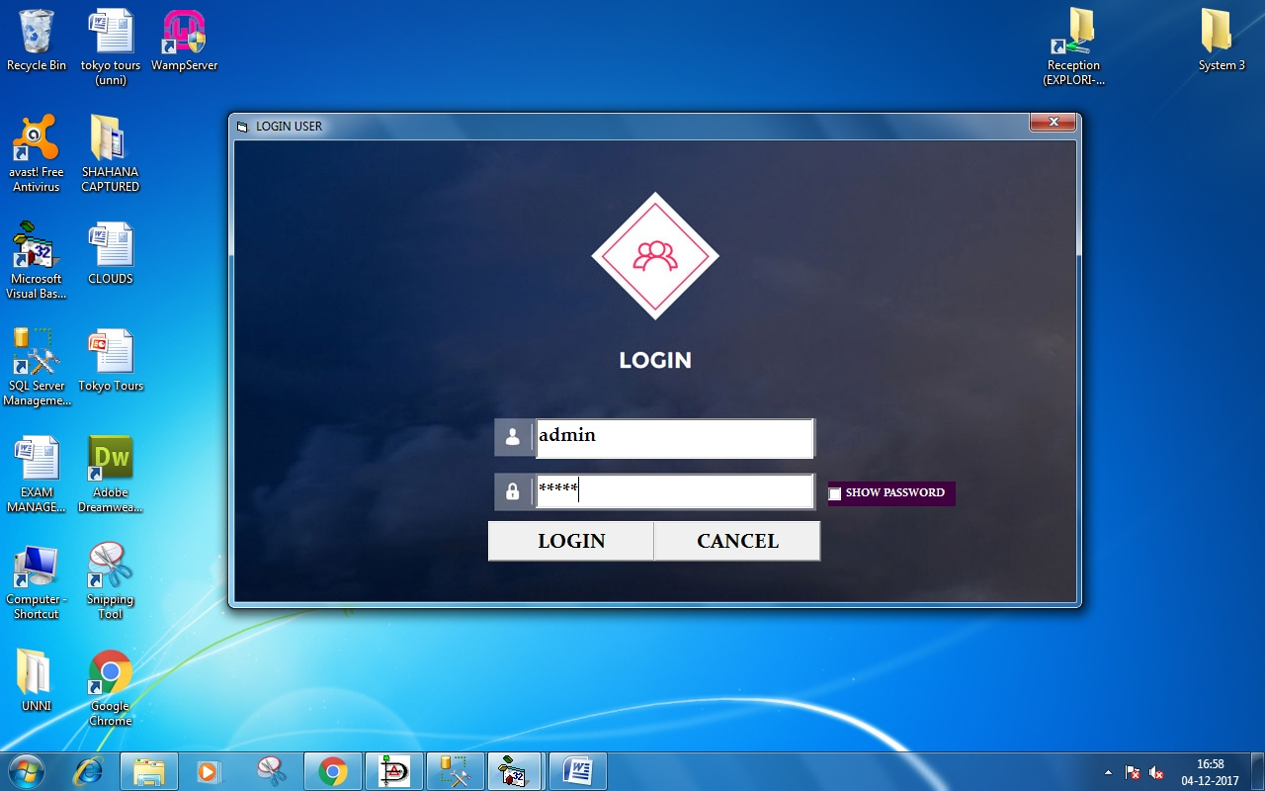

**FORM 2:MDI FORM**

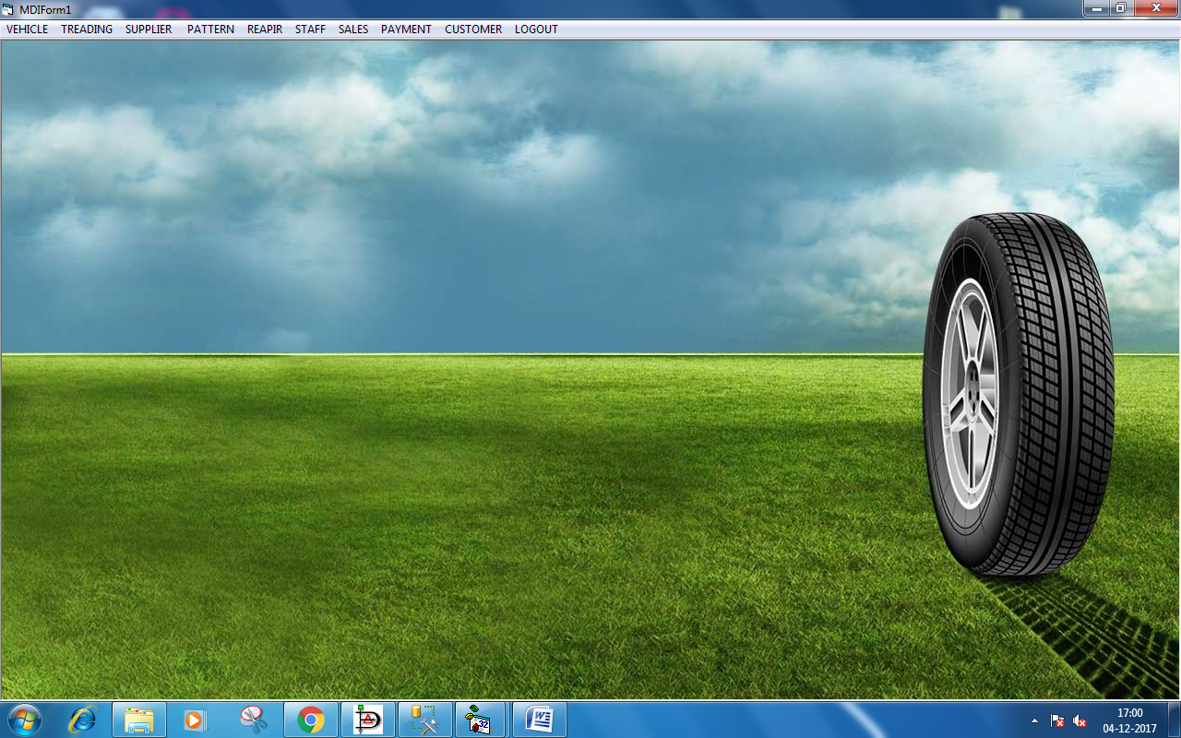

**FORM 3:VEHICLE CATEGORY DETAILS**

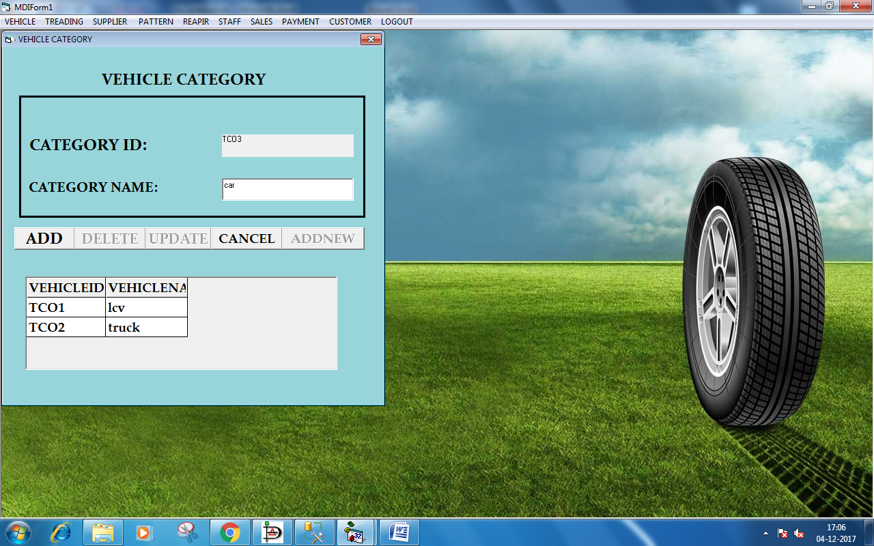

**FORM 4: TREAD TYPE DETAILS**

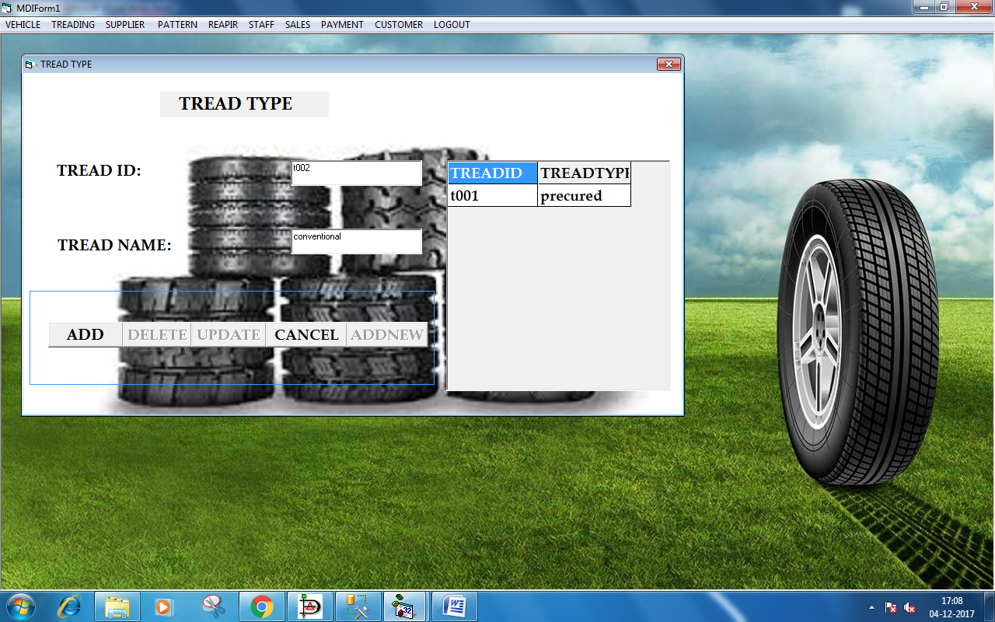

**FORM 5:TYRE TYPE DETAILS**

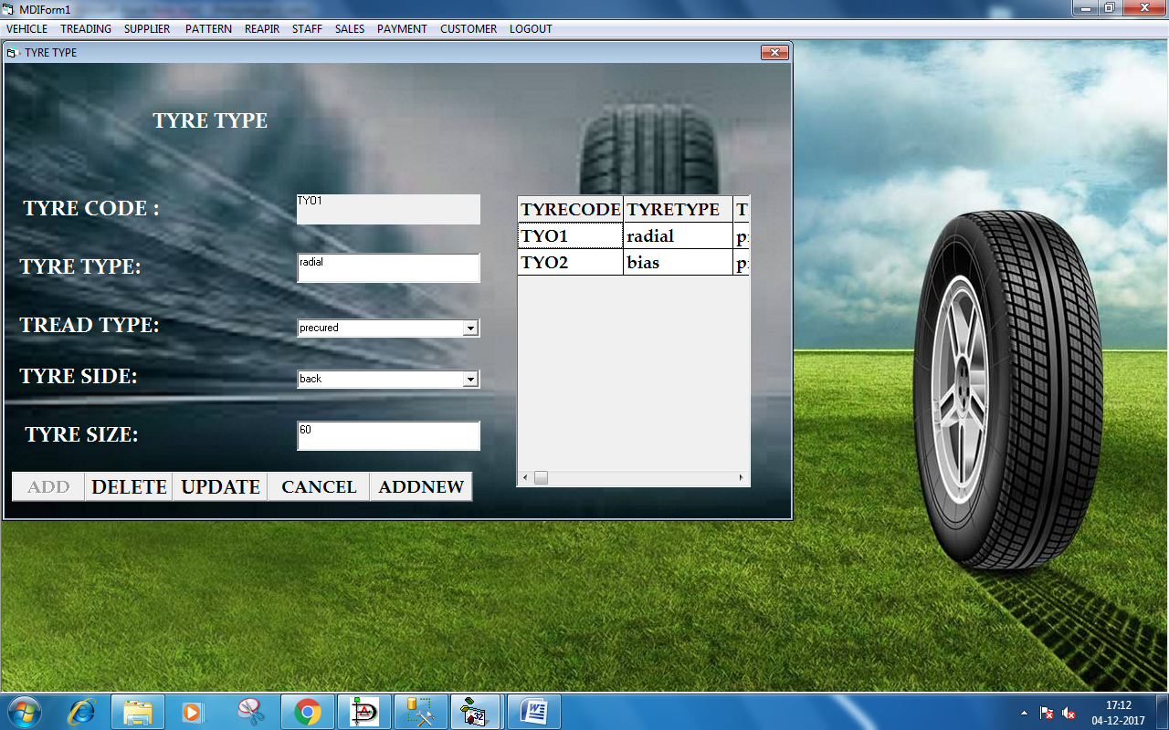

**FORM 6: SUPPLIER DETAILS**

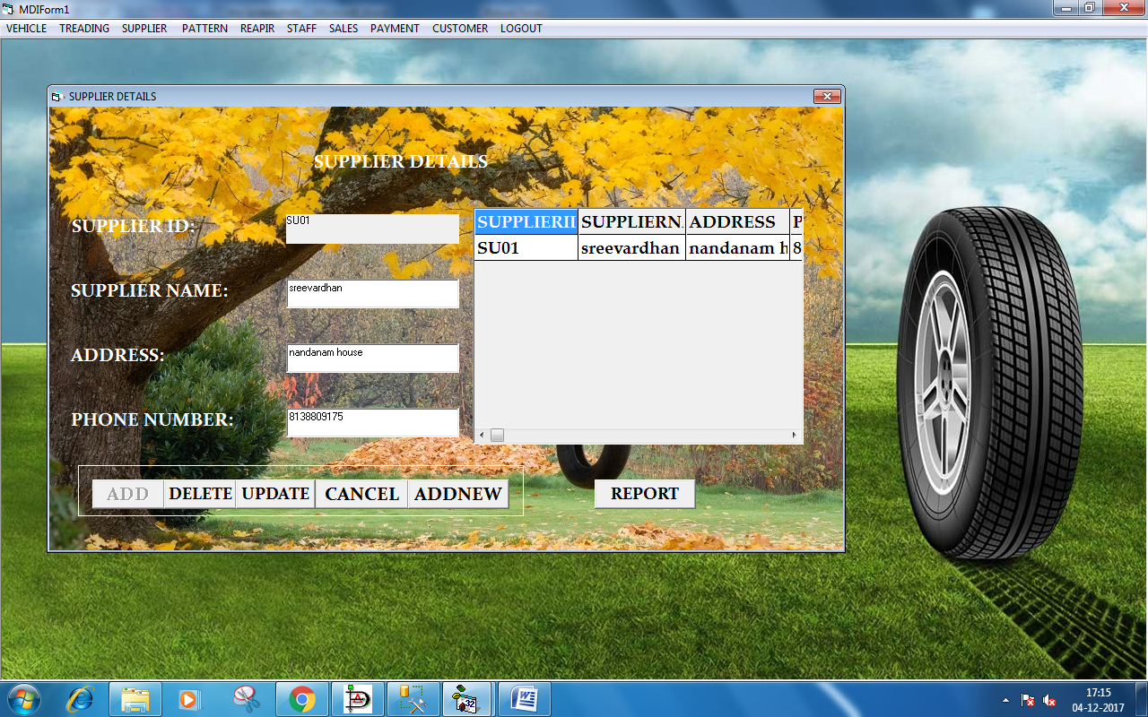

**FORM 7:PATTERN DETAILS**

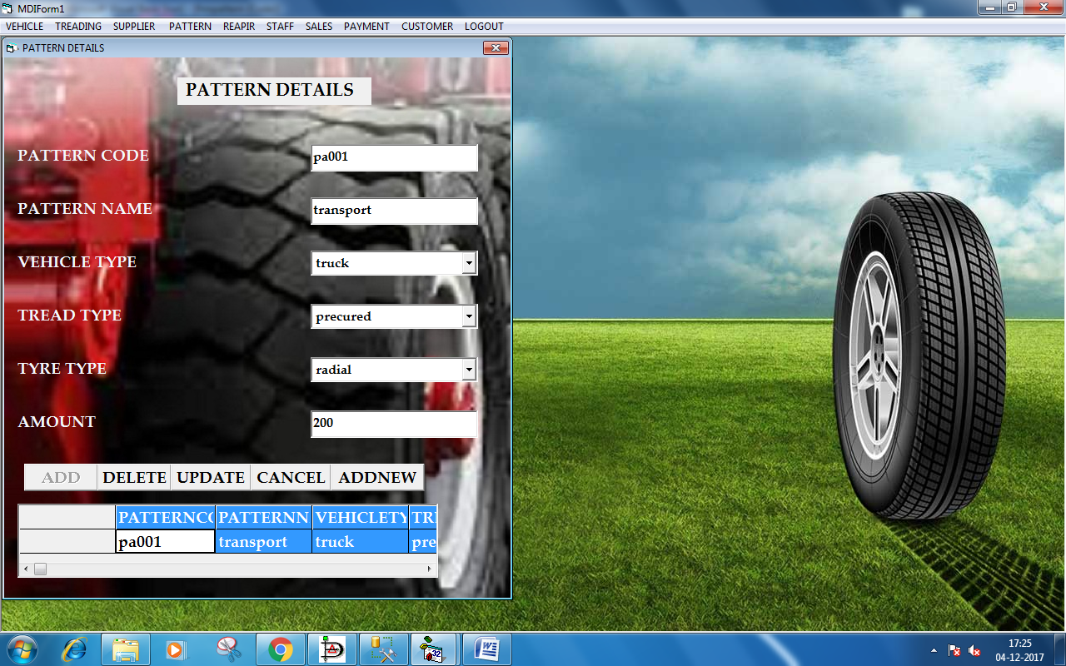

**FORM 8: RAW MATERIAL DETAIL**

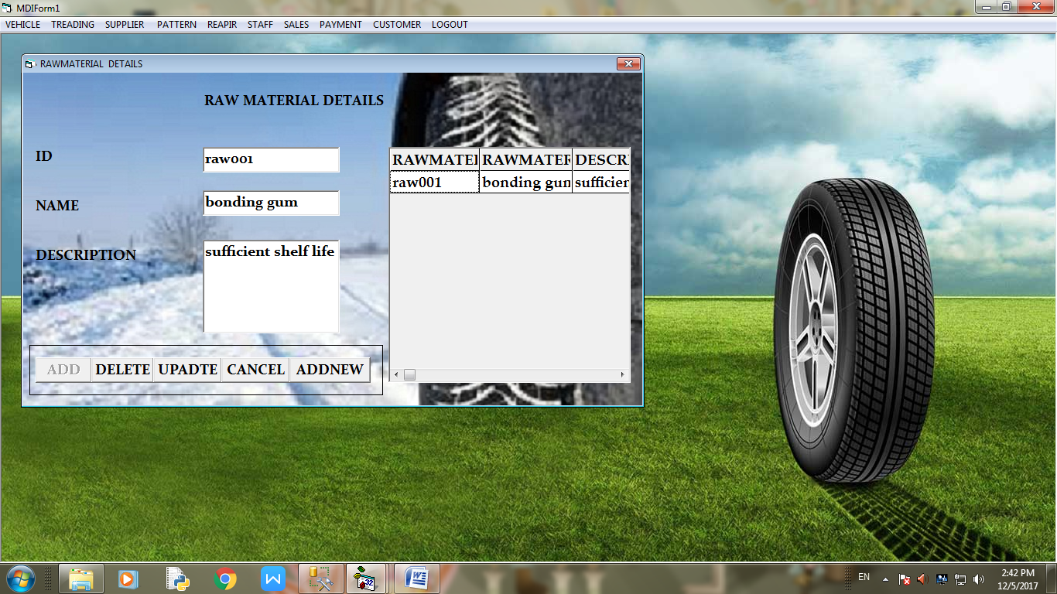

**FORM 9:SUB PATTERN DETAILS**

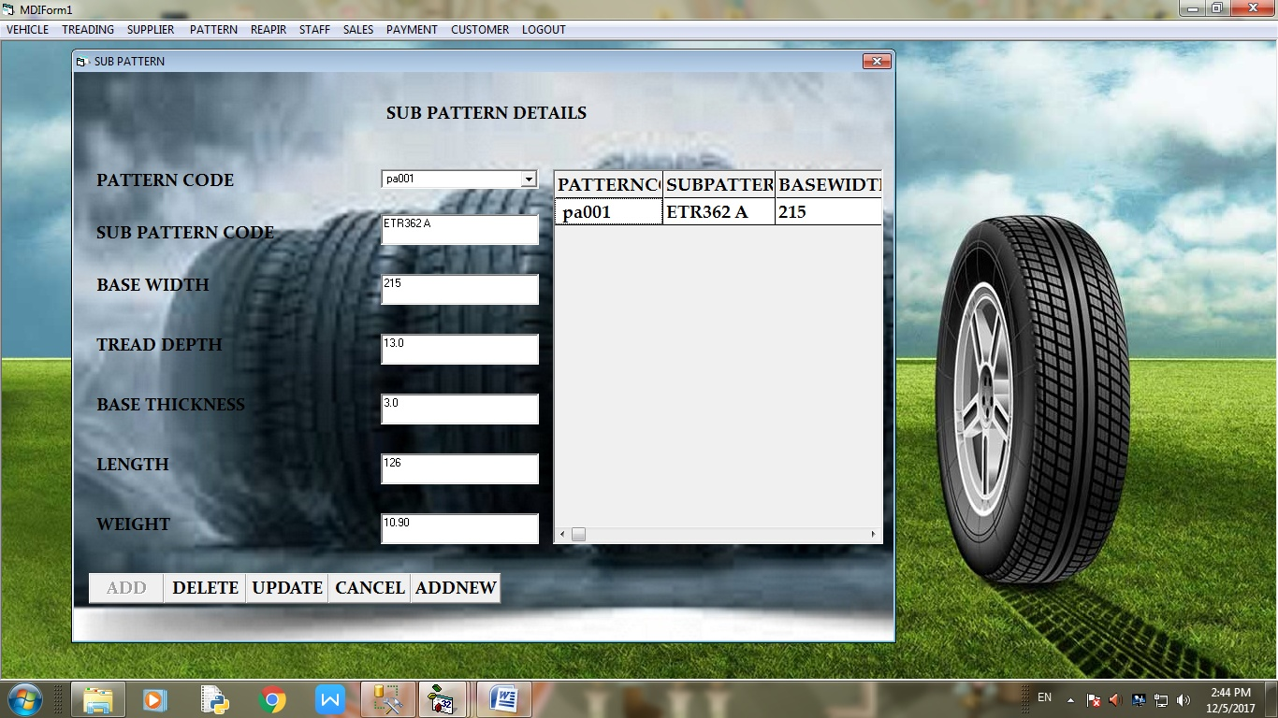

**FORM 10:PURCHASE DETAILS**

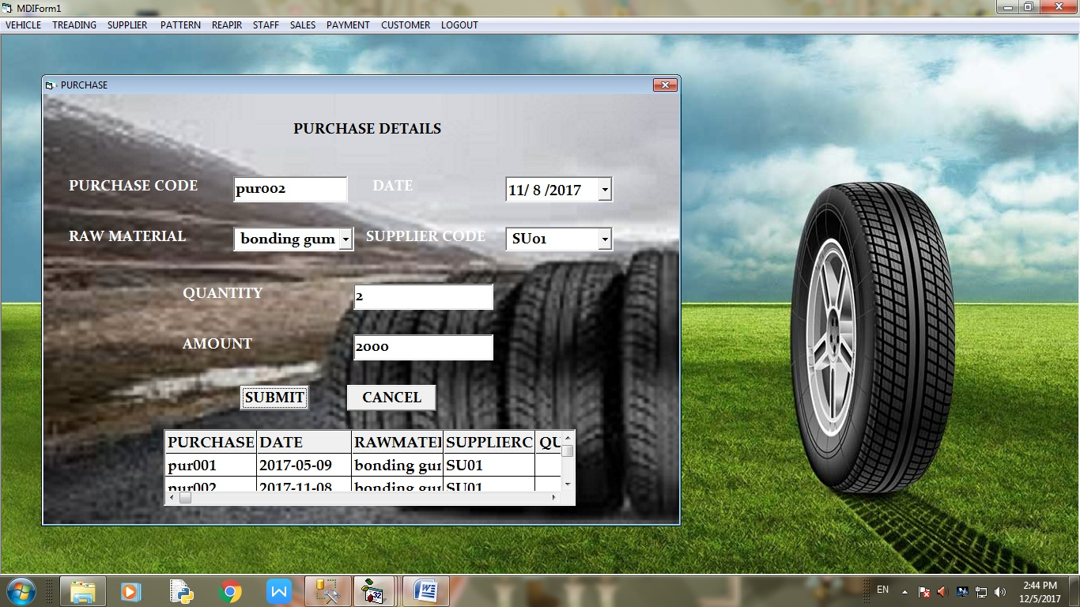

**FORM 11:REPAIR PATCHES DETAILS**

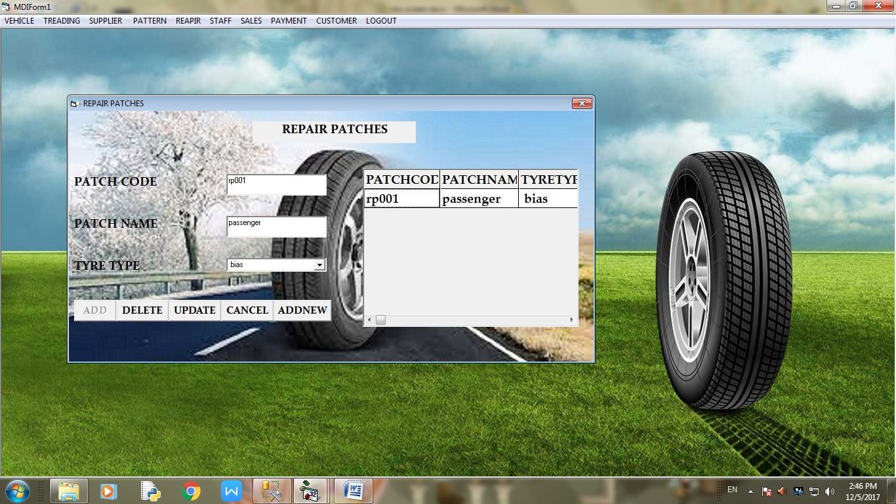

**FORM 12:PATCHPRODUCT DETAILS**

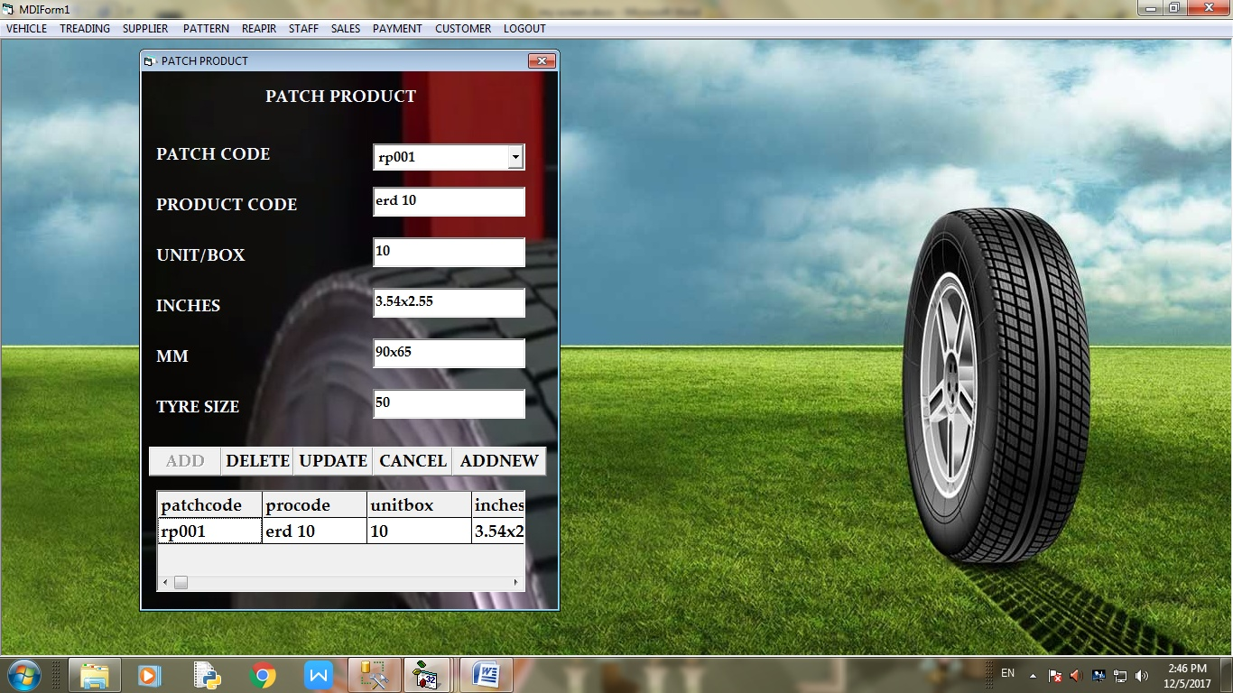

**FORM 13:RETREAD SALE**

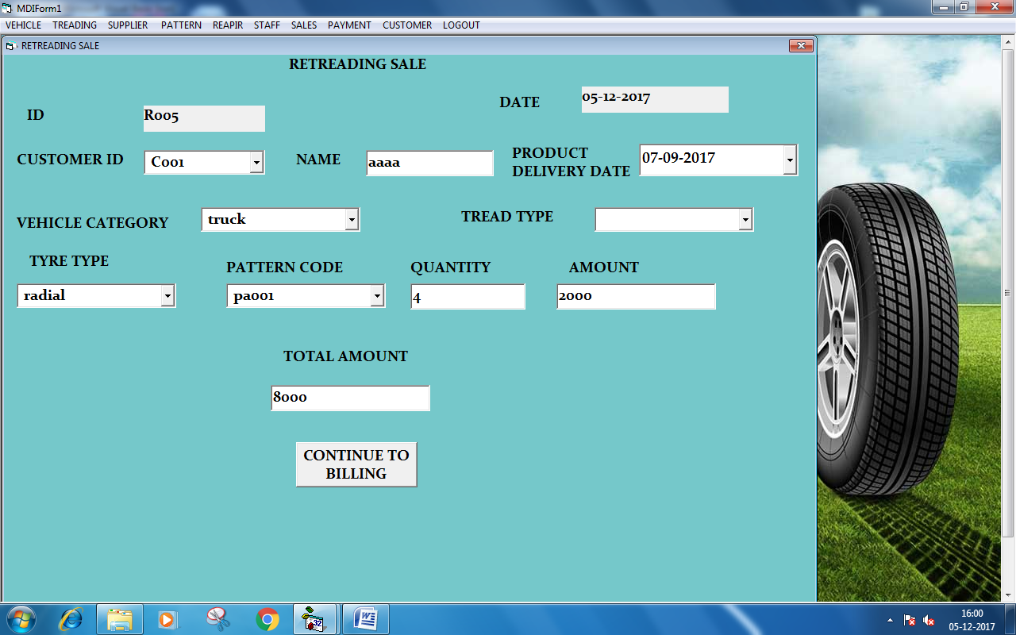

**FORM 14:STAFF DETAILS**

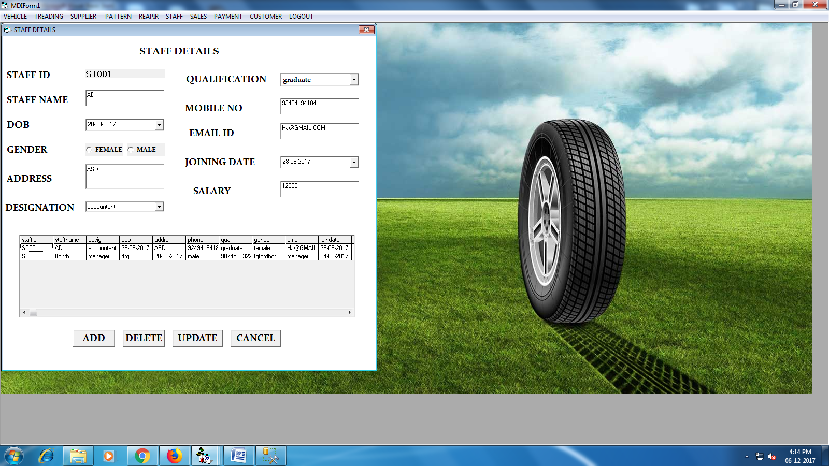

**APPENDIX-C**

**1.SUPPLIER DETAILS REPORT**

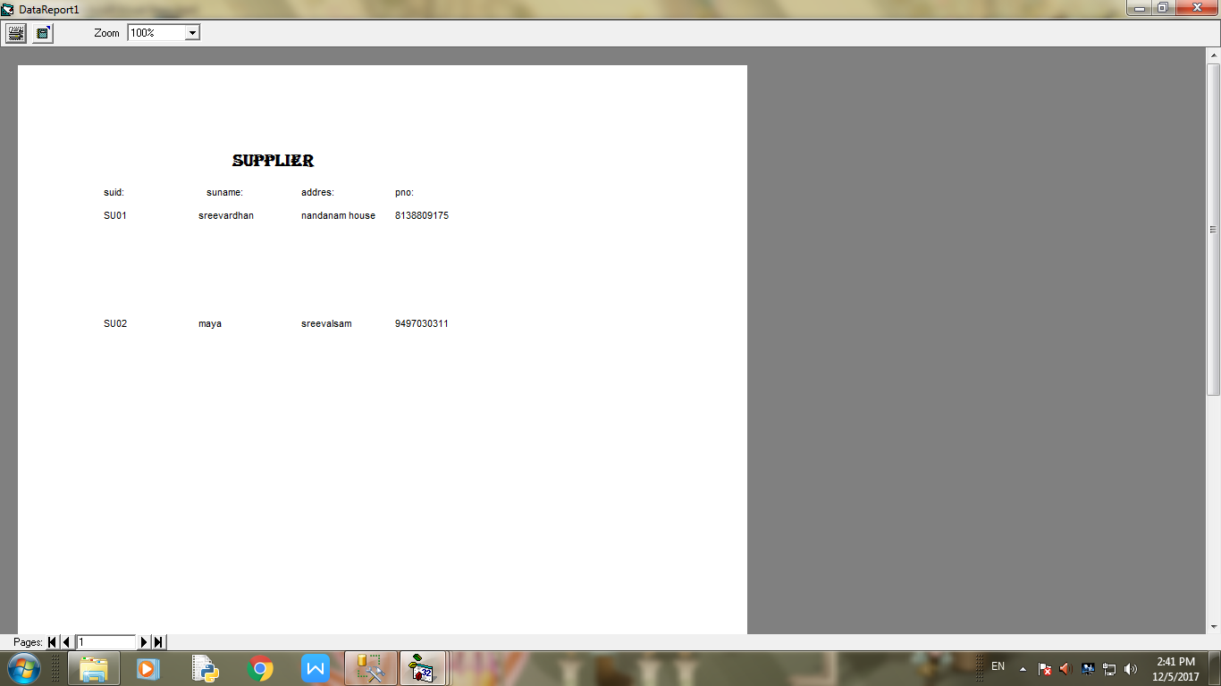

**2.SALARY SLIP**

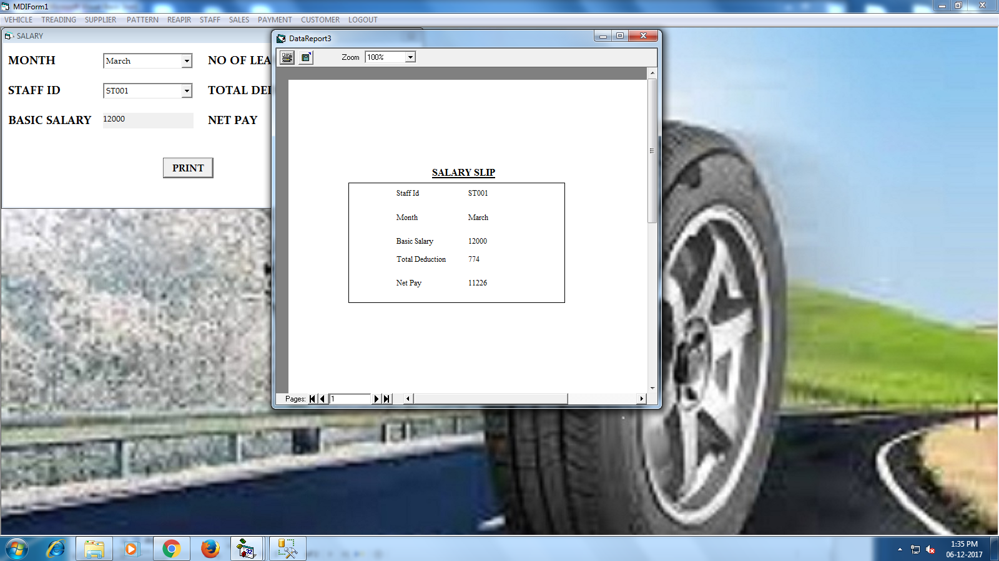

**3.CUSTOMER REPORT**

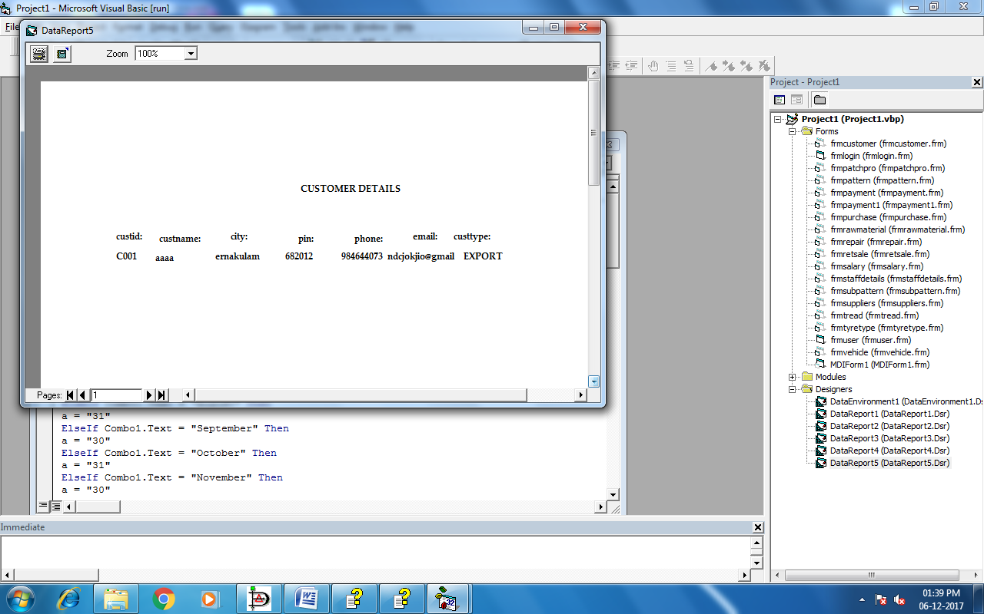

**4.PAYMENT REPORT**

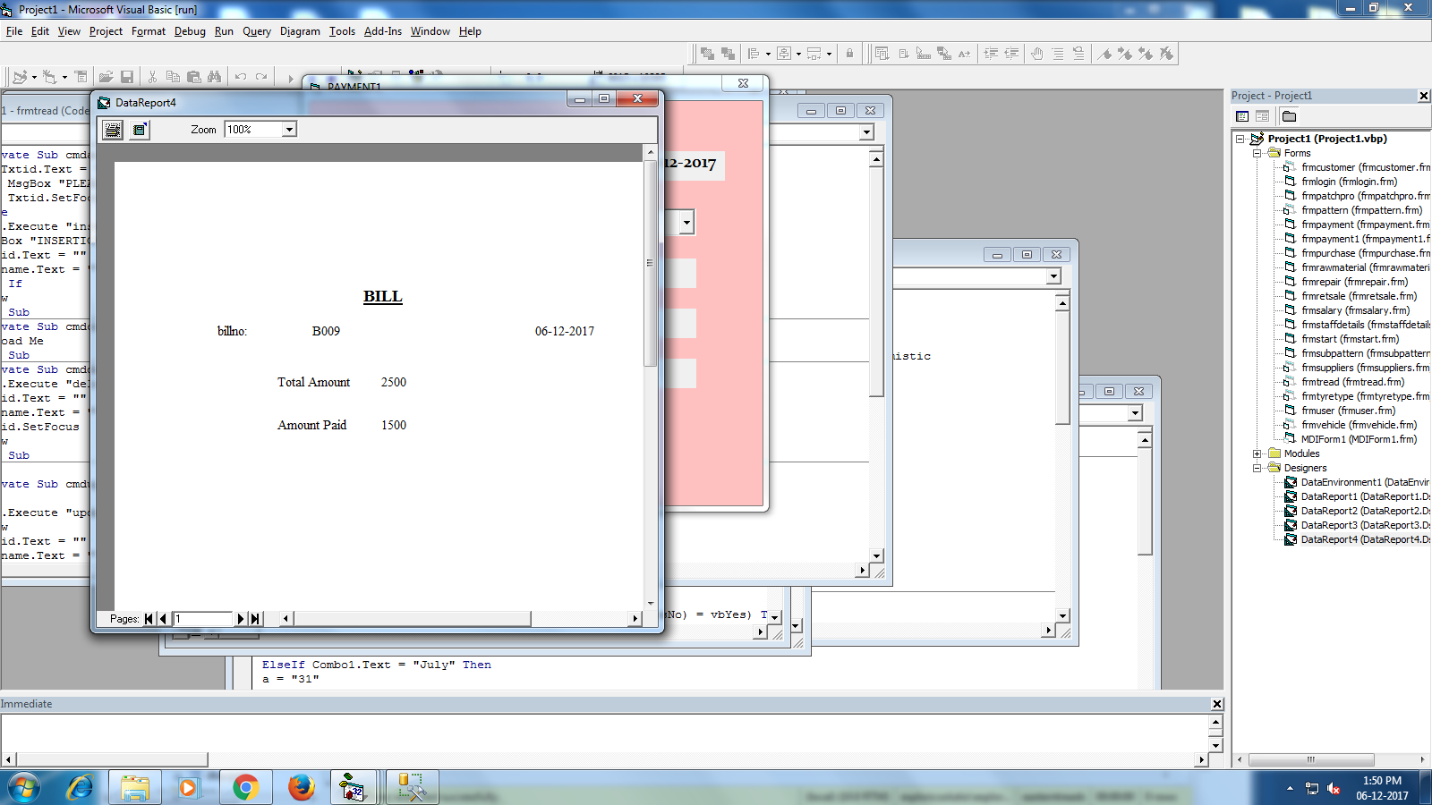

**5.BILL REPORT**

